III. Software Requirements Specification

1. Product Overview
StoryWeaver AI is a Vietnamese web platform that teaches emotional intelligence (EQ) to children aged 5–8 through interactive picture stories built on the CASEL framework. Parents create stories that reflect their child’s real situations (sibling conflicts, handling anger, sharing…) from lesson templates designed by pedagogical specialists; AI drafts the text, illustrations and Vietnamese narration, and the parent reviews every page before the story reaches the child.
Children read in a zero-text Kid Mode protected by an exit PIN and answer checkpoints (emotion picks, perspective and problem-solving choices). Answers are scored on the server against specialist-authored question template versions and turned into an EQ report per CASEL competency and sub-skill for parents.
The platform follows a C2C model: approved sellers can publish de-personalised copies of their stories to a moderated marketplace, buyers pay via payOS VietQR, revenue is split between seller and platform and held before it can be withdrawn. Specialists moderate submissions and monitor published content (reports, auto-suspension, strikes, random audits); Admins manage accounts, plans, settings, refunds, withdrawals and finance. The guiding principle is “AI suggests – humans decide – the system enforces”.
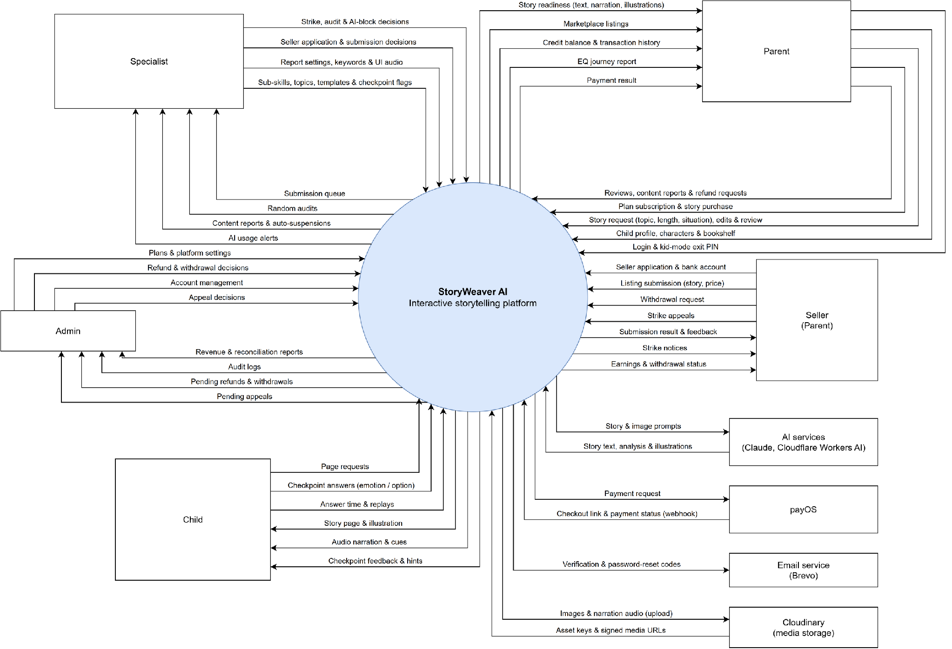
Context Diagram

2. User Requirements

2.1 Actors
# | Actor | Description
1 | Parent | Main user. Manages child profiles and family characters, creates and reviews stories with AI help, manages bookshelves, enters Kid Mode, buys plans and stories, views EQ reports, reviews and reports content, requests refunds.
2 | Seller | A Parent whose seller application is approved. Publishes de-personalised stories for sale, replies to reviews, tracks earnings, requests withdrawals and appeals strikes.
3 | Child | Uses Kid Mode with a kid session issued by the parent. Reads stories from the bookshelf, listens to narration and answers checkpoints.
4 | Specialist | Pedagogical expert. Manages sub-skills, model stories, question templates, checkpoint review, EQ report settings and blocked keywords; reviews seller applications and submissions; monitors reports, strikes, audits and AI usage.
5 | Admin | Platform administrator. Manages accounts and specialists, plans, platform settings, refunds, withdrawals, strike appeals, finance reports and audit logs.

2.2 Use Case Diagrams

2.2.1 Diagram(s)
Use Case Diagram

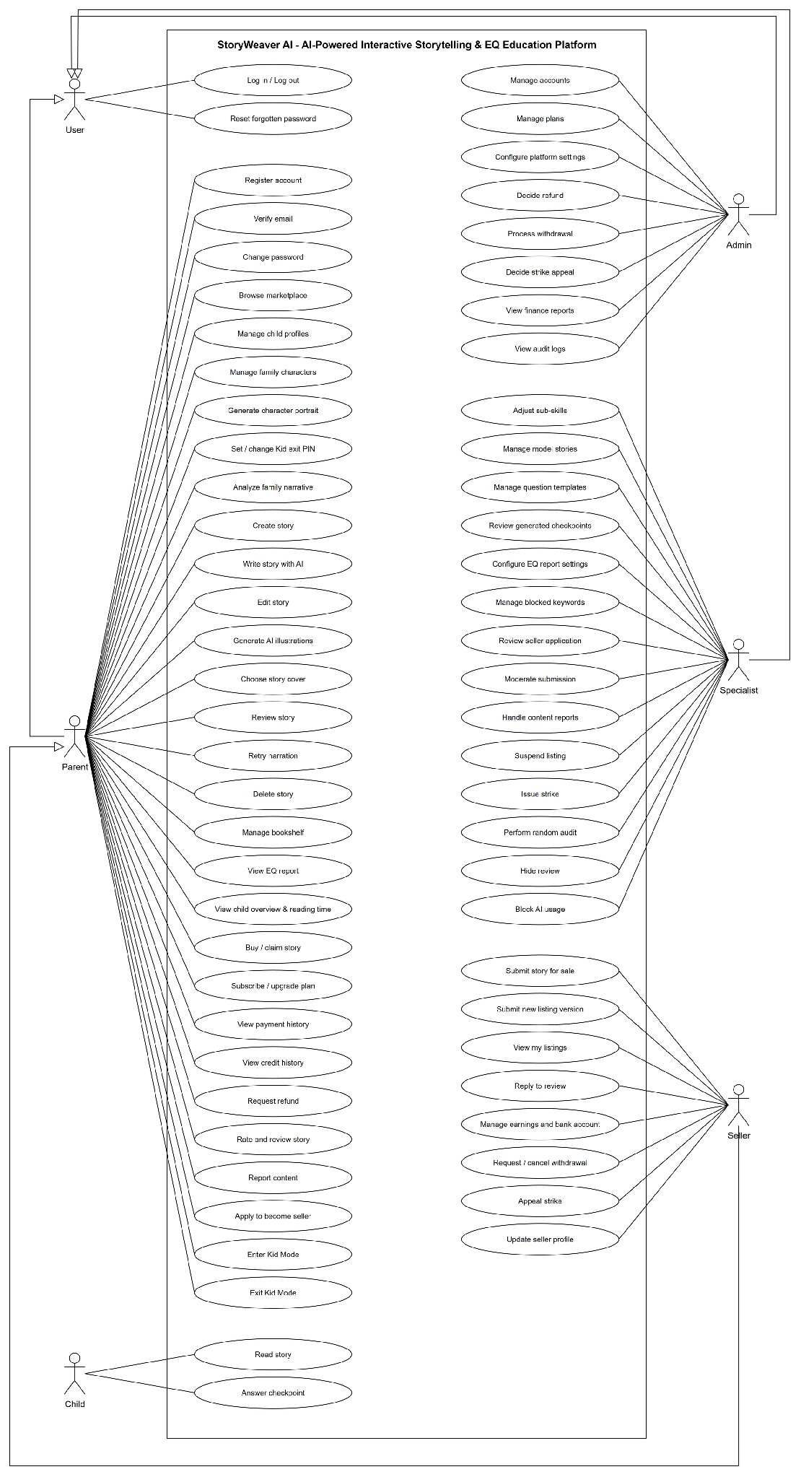

2.2.2 Descriptions

ID | Use Case | Actors | Use Case Description
UC-01 | Register account | Parent | Create a parent account with the Free plan.
UC-02 | Log in / Log out | Parent, Specialist, Admin | Sign in with email or username and password; sign out.
UC-03 | Reset forgotten password | Parent, Specialist, Admin | Receive a recovery code by email and set a new password.
UC-04 | Change password | Parent | Change the password while signed in.
UC-05 | Manage child profiles | Parent | Create, update and delete child profiles within the plan limit.
UC-06 | Manage family characters | Parent | Create, update and delete characters described by text, within the plan's character limit. Each child can have at most one representative character.
UC-07 | Generate character portrait | Parent | Request one AI portrait per character using credits.
UC-08 | Set / change Kid exit PIN | Parent | Set or change the PIN that protects Kid Mode exit.
UC-09 | Create story | Parent | Create a story draft from one of three entries: a model story (pick a model story, characters and length), a family story (from an analysed family narrative), or a handwritten story (custom length, no template).
UC-10 | Write story with AI | Parent | Let AI write the story from the template or the analysed narrative; credits are held, then consumed on success or released on failure.
UC-11 | Edit story | Parent | Edit page content. Checkpoints can be added, edited or removed only in handwritten stories; in AI stories they are locked to the template.
UC-12 | Generate AI illustrations | Parent | Draw scene images (max 4 per story) and missing portraits with credits.
UC-13 | Review story | Parent | Review every page and complete the review; narration is generated.
UC-14 | Retry narration | Parent | Retry narration clips that failed.
UC-15 | Manage bookshelf | Parent | Add or remove stories ready for children on a child’s bookshelf.
UC-16 | View EQ report | Parent | View competency radar, sub-skill levels, evidence, tips and suggested model stories; only first plays are counted.
UC-17 | Enter Kid Mode | Parent | Start a kid session for a child.
UC-18 | Read story | Child | Open a ready story from the bookshelf, listen to narration, pause / play, resume an unfinished session, replay.
UC-19 | Answer checkpoint | Child | Choose an emotion or option; emotion and perspective questions give a hint and a second try when the first answer is wrong. Only the first answer is scored.
UC-20 | Exit Kid Mode | Parent | Leave Kid Mode with the parent PIN.
UC-21 | Browse marketplace | Parent | Search, filter (by price range, free stories included) and sort published stories; view listing detail and reviews.
UC-22 | Buy / claim story | Parent | Buy a paid story via payOS or claim a free one; a duplicate purchase opens a refund request automatically.
UC-23 | Subscribe / upgrade plan | Parent | Pay for a plan via payOS to get monthly credits and limits; an upgrade mid-period starts a new period at once and keeps the remaining credits one time.
UC-24 | View payment history | Parent | View paid orders and refund eligibility.
UC-25 | Request refund | Parent | Request a refund for a paid item within the refund window.
UC-26 | Rate and review story | Parent | Rate and review a purchased story after a child has finished reading it.
UC-27 | Report content | Parent | Report a listing or a review with a report category.
UC-28 | Apply to become seller | Parent | Submit a seller application.
UC-29 | Submit story for sale | Parent | As an approved seller, create a de-personalised listing with a self-set price (free, or 5,000–500,000 VND in steps of 1,000) and character aliases. Real names, situation and family narrative are removed; narration is regenerated with generic names.
UC-30 | View my listings | Parent | As a seller, track moderation status and feedback.
UC-31 | Reply to review | Parent | As a seller, reply once to a customer review.
UC-32 | Manage earnings and bank account | Parent | As a seller, view pending / available earnings and set the bank account.
UC-33 | Request / cancel withdrawal | Parent | As a seller, request a withdrawal or cancel it before approval.
UC-34 | Appeal strike | Parent | As a seller, view strikes and appeal an active one.
UC-35 | Adjust sub-skills | Specialist | Adjust the standard CASEL sub-skills: name, description, age range, enable / disable. Sub-skills cannot be added or deleted.
UC-36 | Manage model stories | Specialist | Manage model stories (“Chuyện mẫu”) with 1–3 sub-skills and suggested plot guidance.
UC-37 | Manage question templates | Specialist | Write question templates per sub-skill: edit drafts, publish versions, duplicate templates.
UC-38 | Review generated checkpoints | Specialist | Mark checkpoints OK or flag them out of scoring (the flag can be removed).
UC-39 | Configure EQ report settings | Specialist | Set the report window and level thresholds.
UC-40 | Manage blocked keywords | Specialist | Manage block / warn keywords, including bulk import.
UC-41 | Review seller application | Specialist | Approve or reject seller applications.
UC-42 | Moderate submission | Specialist | Claim a submission (only after narration is ready), view 100% of the pages before approving; request changes, reject or take down with a required comment.
UC-43 | Handle content reports | Specialist | Dismiss reports or decide follow-up reviews; a listing reaching the report threshold is suspended automatically.
UC-44 | Suspend listing | Specialist | Suspend a published listing.
UC-45 | Issue strike | Specialist | Issue a strike to a seller.
UC-46 | Perform random audit | Specialist | Decide random audit reviews; run an audit batch.
UC-47 | Hide review | Specialist | Hide a violating product review.
UC-48 | Block AI usage | Specialist | View AI usage alerts; block AI for a parent for up to 90 days or unblock it.
UC-49 | Manage accounts | Admin | Lock / unlock accounts, create specialist accounts.
UC-50 | Manage plans | Admin | Create and edit subscription plans.
UC-51 | Configure platform settings | Admin | Edit AI costs, market and moderation settings.
UC-52 | Decide refund | Admin | Approve with bank reference or reject refunds.
UC-53 | Process withdrawal | Admin | Mark a withdrawal paid after transferring the money manually (optional bank reference), or reject it.
UC-54 | Decide strike appeal | Admin | Approve or reject appeals.
UC-55 | View finance reports | Admin | Dashboard overview, revenue, AI cost, profit and loss, reconciliation (with counter fix).
UC-56 | View audit logs | Admin | View Admin and Specialist action logs.
UC-57 | Analyze family narrative | Parent | Send the parent's account of a real family moment for AI analysis. The AI returns a summary, a seed event and 1–2 suggested sub-skills, and no credits are charged. Daily limit applies.
UC-58 | Choose story cover | Parent | Pick a scene that already has an image as the story cover. The default cover is scene 1.
UC-59 | Delete story | Parent | Delete (soft-delete) one of the parent's own private stories.
UC-60 | View child overview & reading time | Parent | View a child's overview: recent story, reading time per day calculated from play sessions (no screen-time limit), and EQ summary.
UC-61 | Submit new listing version | Seller | Submit a new version of a published listing from the updated story. The published version stays on sale until the new one is approved; only one version can wait for review at a time.
UC-62 | Update seller profile | Seller | Update the seller display name, bio and expertise while the profile is pending or approved.
UC-63 | Verify email | Parent | Verify the account email with the code sent by email, from the banner or Settings.
UC-64 | View credit history | Parent | View the credits granted each month and the credits held, spent and released by AI generation.

3. Functional Requirements

3.1 System Functional Overview

3.1.1 Screens Flow
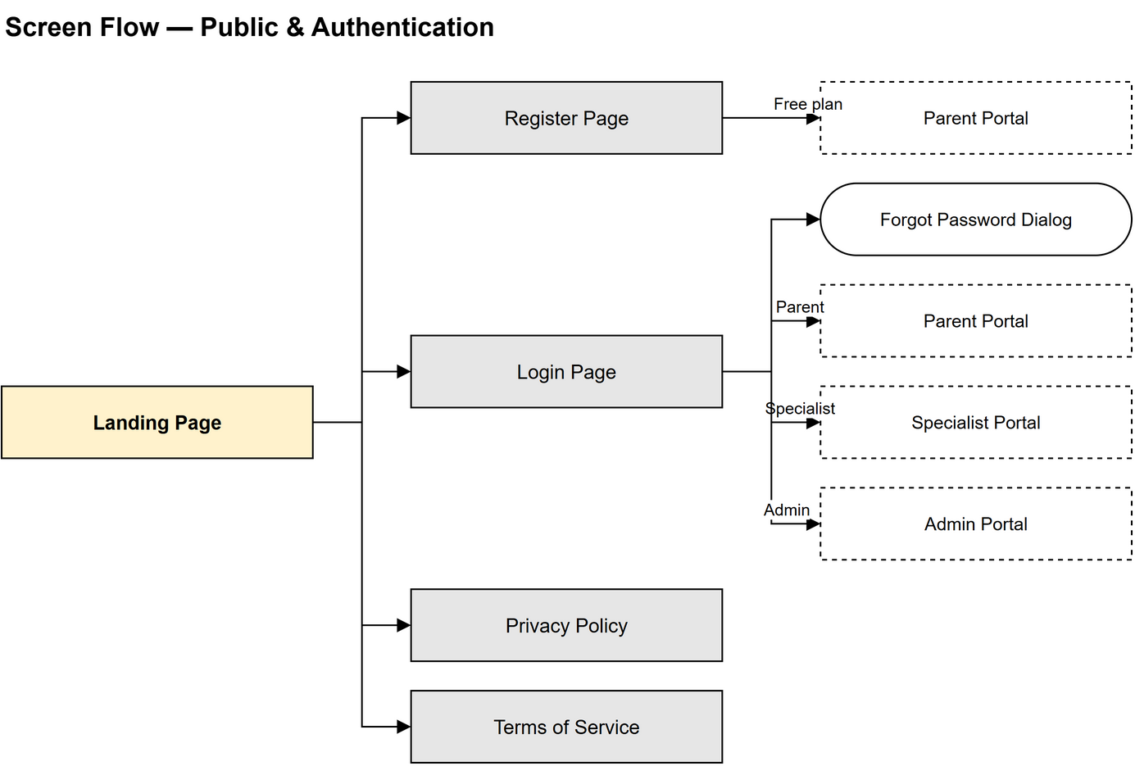
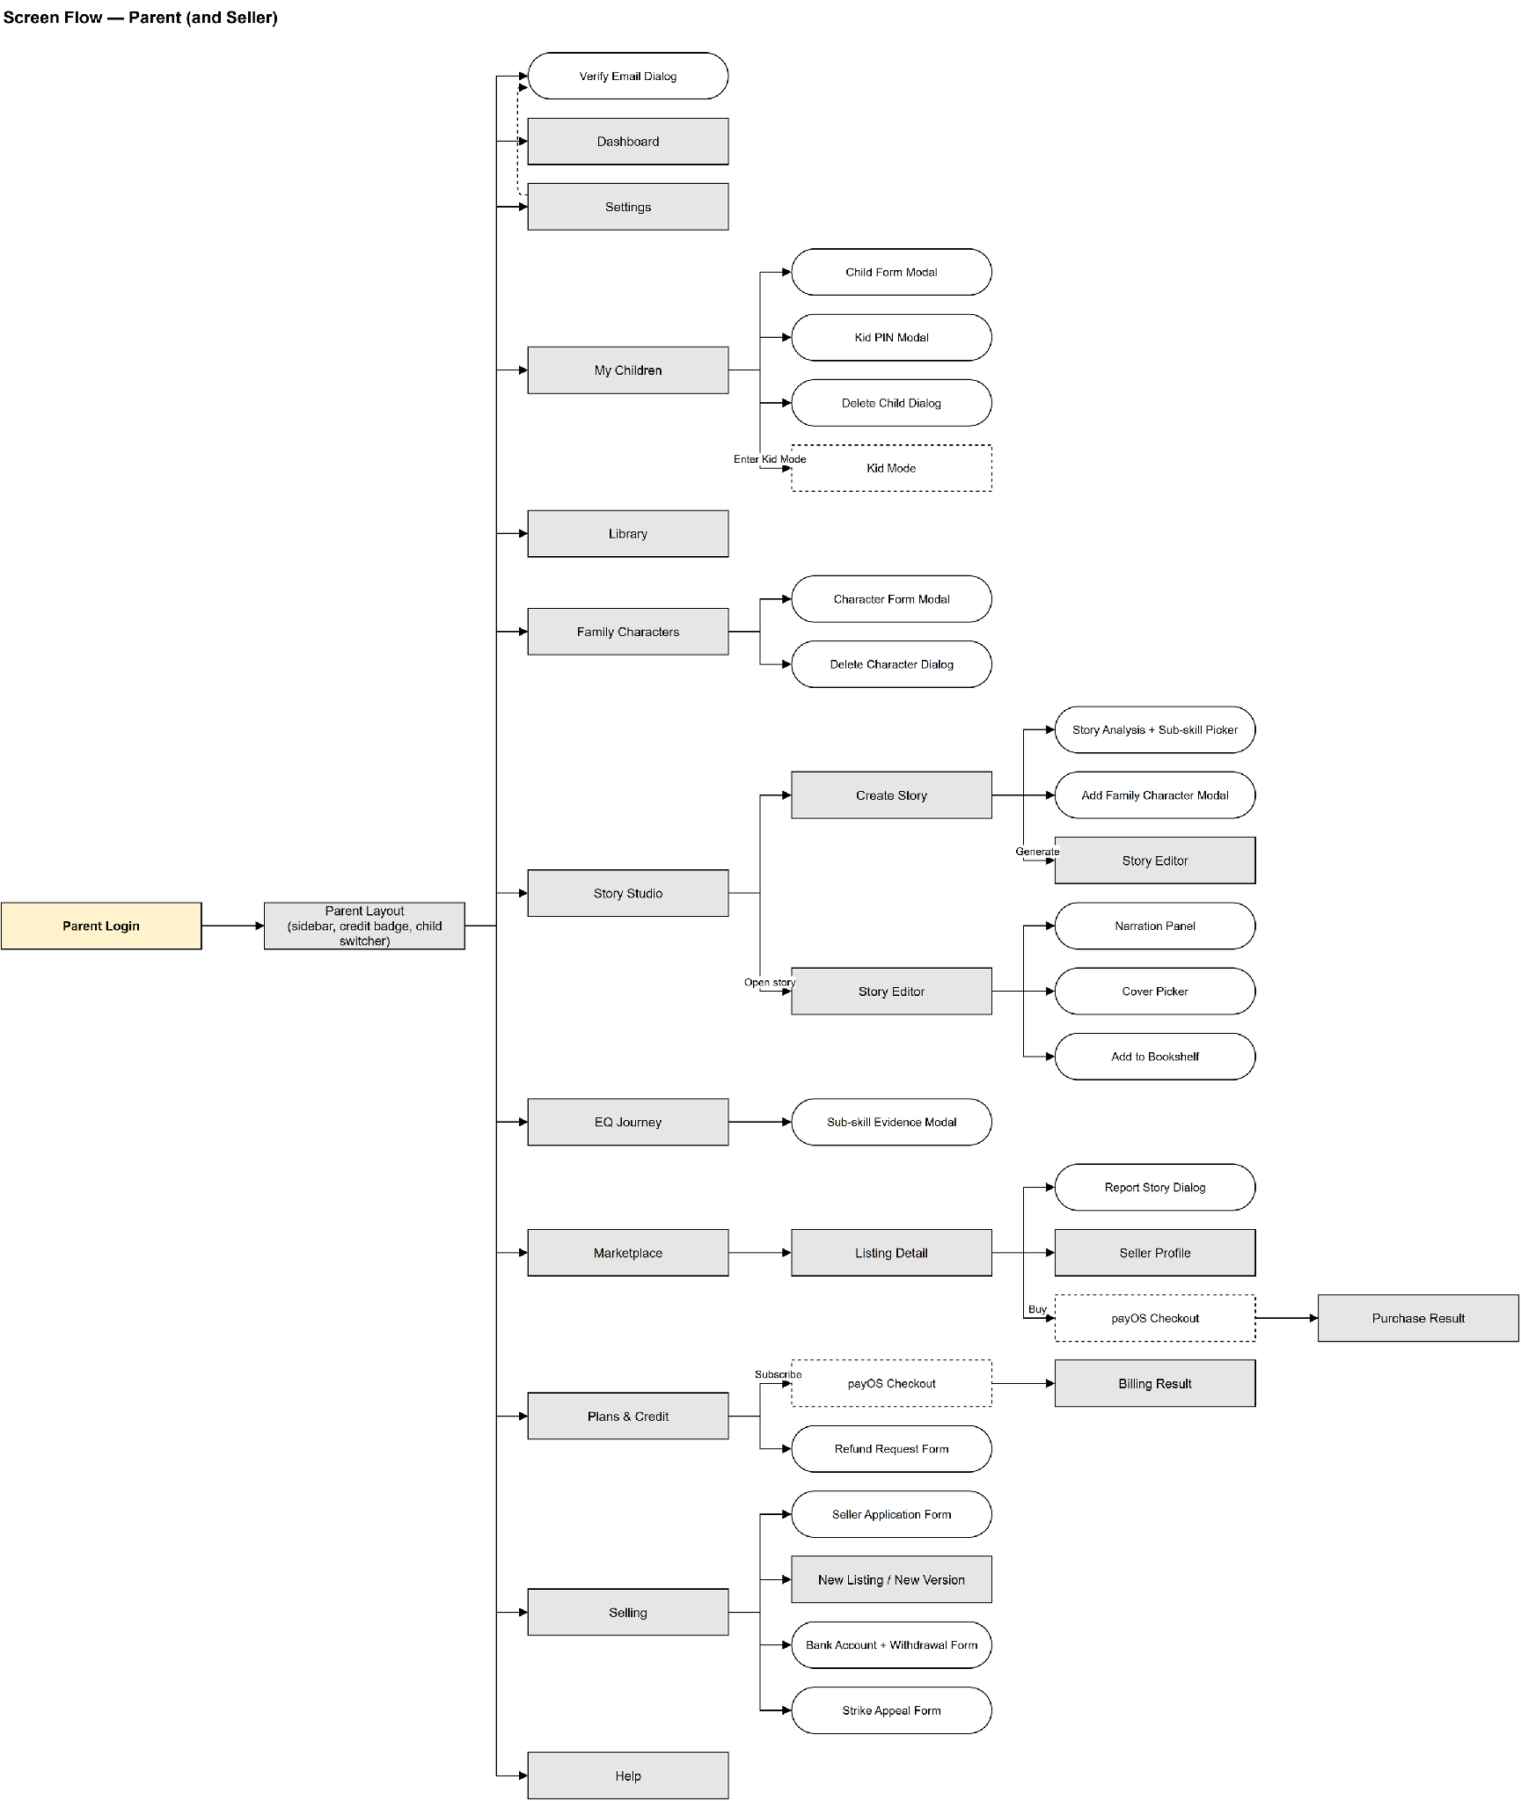
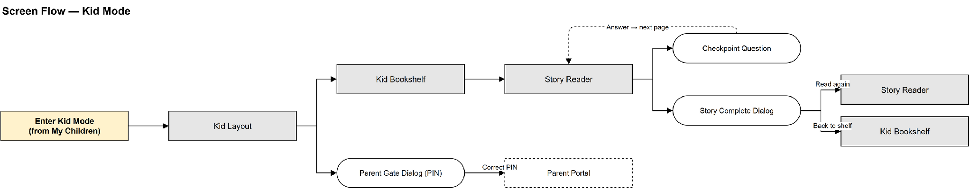
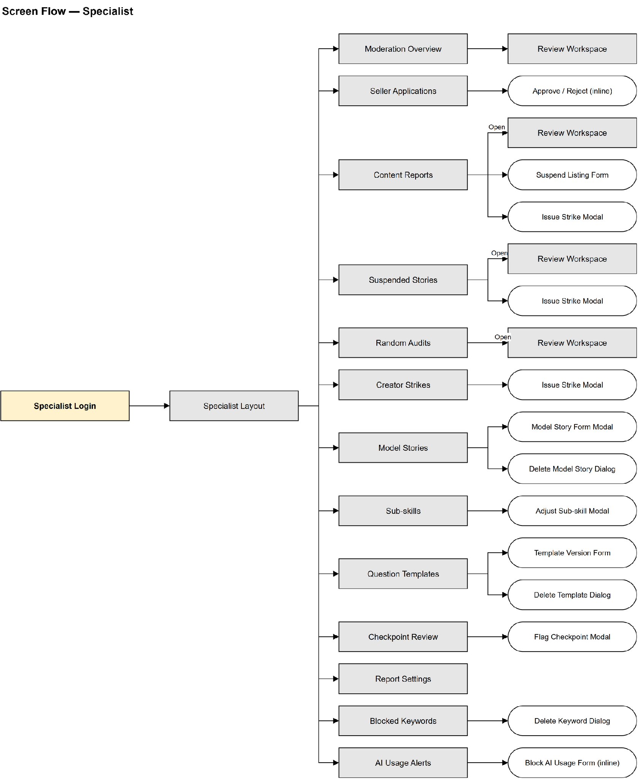
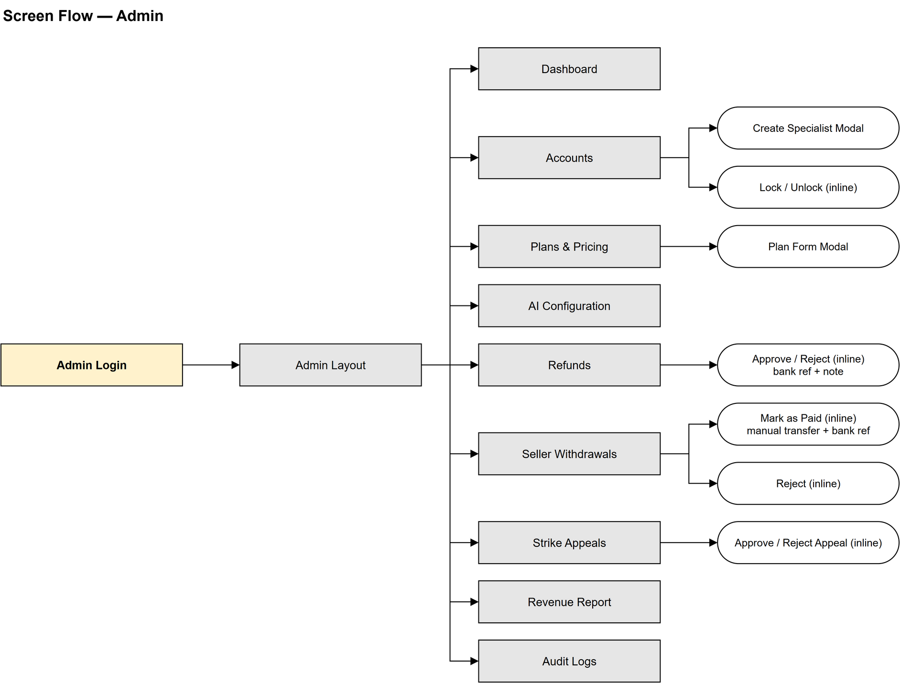

3.1.2 Screen Descriptions
WEB – Public & Authentication Screens
# | Feature | Screen | Description
1 | Homepage | Landing Page | Public landing page: hero, how it works (3 steps), the 5 CASEL competencies, FAQ and sign-up banner. Signed-in users are redirected to the home page of their role.
2 | Authentication | Register | Parent sign-up form (full name, username, email, phone, password, confirm password). Creates the account, wallet and Free plan subscription, sends a verification code by email and opens the Parent portal.
3 | Authentication | Login | Sign-in with email or username and password. Redirects to the Parent, Specialist or Admin portal by role.
4 | Authentication | Forgot Password Dialog | Dialog opened from Login in three steps: enter the email, enter the code received by email, set a new password.
5 | Legal | Privacy Policy / Terms | Static pages linked from the landing page footer.

WEB (Parent / Seller) – Parent Portal
# | Feature | Screen | Description
1 | Layout | Parent Layout | Sidebar with 11 items, remaining AI credit badge, child switcher and the email verification banner.
2 | Account | Verify Email Dialog | Opened from the verification banner or Settings: paste the code sent by email (valid 24 hours) or resend it.
3 | Dashboard | Dashboard | Today’s reading time and sessions, finished stories, stories waiting for review, EQ radar of the selected child, continue reading, drafts to review and best sellers on the marketplace.
4 | Family Profile | My Children | Child cards with reading settings, the Kid Mode PIN card and the Enter Kid Mode button.
5 | Family Profile | Child Form Modal / Delete Child Dialog | Create or edit a child profile (name, birth date, appearance, voice); confirm soft-deletion.
6 | Family Profile | Kid PIN Modal | Set or change the PIN that is required to leave Kid Mode.
7 | Family Profile | Family Characters | Character cards with AI portrait and the character limit of the current plan.
8 | Family Profile | Character Form Modal / Delete Character Dialog | Create or edit a character (name, text-only appearance, linked child, request one AI portrait); confirm deletion.
9 | Story Creation | Story Studio | The parent’s stories in two tabs: waiting for parent review and completed.
10 | Story Creation | Create Story | Choose one of three entries – Family story (tell what happened), Model story (pick a Specialist topic) or Handwritten – then characters, length and story info (title, narration, AI images).
11 | Story Creation | Story Analysis + Sub-skill Picker | Family entry only: the AI reads the tokenised story (no credit) and proposes 1–2 sub-skills; the parent confirms or changes them before the story is created.
12 | Story Creation | Add Family Character Modal | Quick-add a family character without leaving Create Story.
13 | Story Creation | Story Editor | AI writing progress, page editor and checkpoint editor, AI scene illustrations, page-by-page review and “Complete”.
14 | Story Creation | Narration + Cover + Bookshelf panels | Narration progress and retry, choose the cover scene, add the ready story to a child’s bookshelf.
15 | Bookshelf | Library | Continue reading row and the stories on each child’s bookshelf, in grid or list view.
16 | EQ Report | EQ Journey | Per-child report: 5 CASEL competencies, sub-skill levels, weekly trend, conversation tips and suggested model stories.
17 | EQ Report | Sub-skill Evidence Modal | Answers that support the level of one sub-skill.
18 | Marketplace | Marketplace | Published stories with search, filters (competency, age, price range, narration) and sorting (best-selling, newest, rating, price low to high).
19 | Marketplace | Listing Detail | Cover, seller, first-page preview with generic names, rating distribution and reviews, Buy through payOS or Get for free.
20 | Marketplace | Report Story Dialog | Report a listing or a review with a category and a note.
21 | Marketplace | payOS Checkout / Purchase Result | External payOS page; on return the result page shows the order status (paid, cancelled, expired).
22 | Billing | Plans & Credit | Current plan and remaining credits, plan list with checkout, payment history.
23 | Billing | payOS Checkout / Billing Result | External payOS page for a plan; the result page shows the new subscription.
24 | Billing | Refund Request Form | Inline form in the payment history for payments still inside the refund window.
25 | Selling | Selling | Seller profile status, listed stories with moderation result, earnings (held / available / withdrawing) and strikes.
26 | Selling | Seller Application Form | Apply to become a seller (needs a plan that allows selling).
27 | Selling | New Listing | Pick a completed private story, title, description, price (5,000–500,000 VND, step 1,000) or free, generic alias names and narration option, then submit for moderation.
28 | Selling | Bank Account + Withdrawal Form | Save the payout bank account and request a withdrawal; shows withdrawal history and status.
29 | Selling | Strike Appeal Form | Appeal an active strike with an explanation.
30 | Account | Settings | Account information, email verification and change password. The Kid Mode PIN is on My Children.
31 | Help | Help | Usage guide for parents.

WEB (Kid Mode) – Child Screens
# | Feature | Screen | Description
1 | Kid Mode | Kid Layout | Full-screen layout without sidebar and with large buttons; opened from My Children with a kid session.
2 | Kid Mode | Kid Bookshelf | Covers of the stories on the child’s bookshelf that are ready (reviewed and, when narration is on, fully narrated).
3 | Kid Mode | Story Reader | Page illustration and text with narration audio, page navigation, progress saved automatically.
4 | Kid Mode | Checkpoint Question | Question card with answer choices; only the first answer of the first play is scored and the correct answer is never sent to the device.
5 | Kid Mode | Story Complete Dialog | Shown at the end of the story: read again or go back to the bookshelf.
6 | Kid Mode | Parent Gate Dialog | Enter the parent’s Kid PIN to leave Kid Mode and return to the Parent portal.

WEB (Specialist) – Specialist Portal
# | Feature | Screen | Description
1 | Layout | Specialist Layout | Sidebar with 13 items and counters of pending work.
2 | Dashboard | Moderation Overview | Counters (stories to review, seller applications, open reports) and the story review queue; claim a submission once its narration is ready.
3 | Publishing | Review Workspace | Read every page (coverage tracked), fill the 7-rule checklist and decide: approve, request changes or reject; for follow-up reviews keep the story or take it down with a strike.
4 | Publishing | Seller Applications | Pending / approved / rejected applications; approve or reject.
5 | Content Library | Model Stories (Topics) | List with filters; Model Story Form Modal to create or edit (competency, age range, 1–3 sub-skills, suggested plot); confirm deletion.
6 | Content Library | Sub-skills | Standard CASEL catalogue with status filter; Adjust Sub-skill Modal edits name, description, age range and on / off (no create or delete).
7 | Content Library | Question Templates | Templates per sub-skill with versions; Version Form to edit the draft, publish it or duplicate the template; confirm deletion.
8 | Content Library | Checkpoint Review | Queue of AI checkpoints made from templates (pending / OK / flagged) and statistics per template; Flag Question Modal excludes a checkpoint from scoring.
9 | Content Library | Report Settings | Parameters of the EQ report (answer window, minimum answers, level thresholds).
10 | Content Library | Blocked Keywords | Add form and list of blocked / warning keywords; change the level or delete.
11 | Monitoring | Content Reports | Reports grouped by listing (open / resolved / dismissed): dismiss, suspend the listing, hide a review or issue a strike.
12 | Monitoring | Suspended Stories | Suspended and archived listings with their follow-up reviews.
13 | Monitoring | Creator Strikes | Active, expired and removed (appeal) strikes per seller.
14 | Monitoring | Strike Modal | Shared by Content Reports, Suspended Stories and Creator Strikes: issue a strike with a reason.
15 | Monitoring | Random Audits | Weekly random audits of published stories; run an audit batch manually.
16 | Monitoring | AI Usage Alerts | Parents with many blocked AI requests; temporarily block or unblock AI usage.

WEB (Admin) – Admin Portal
# | Feature | Screen | Description
1 | Layout | Admin Layout | Sidebar with 9 items.
2 | Dashboard | Dashboard | Paid amount, platform share and seller payable for a period, daily revenue chart, users and seller money, pending withdrawals / refunds / appeals.
3 | Accounts | Accounts | Filter by role, status and keyword, paginated table, lock / unlock; Create Specialist Modal.
4 | Configuration | Plans & Pricing | Subscription plans (Plan Form Modal: price, duration, credits per month, limits, can sell) and settings for the marketplace, refunds and content monitoring.
5 | Configuration | AI Configuration | AI credit costs per action; information about the AI providers (configured in the ai/ service, not on the web).
6 | Finance | Refunds | Pending / refunded / rejected requests; approve with the bank transfer reference and a note, or reject.
7 | Finance | Seller Withdrawals | Requested / paid / rejected / cancelled; after transferring the money manually, mark it paid (optional bank reference) or reject it (returns the money).
8 | Monitoring | Strike Appeals | Pending / approved / rejected appeals; approve or reject.
9 | Finance | Revenue Report | Revenue chart by period and ledger reconciliation with fix of counters.
10 | Oversight | Audit Logs | Paginated log of Admin and Specialist actions.

3.1.3 Screen Authorization
X = allowed. Seller is a Parent with an approved seller profile and has every Parent permission. Child means a kid session token issued by the parent.
Screen / Function | Public | Parent | Seller | Child | Specialist | Admin
Public / Authentication
Landing Page, Privacy Policy, Terms | X | X | X |  | X | X
Register | X
Login / Forgot Password Dialog | X | X | X |  | X | X
Family & Story Creation
My Children / Family Characters |  | X | X
Story Studio / Create Story / Story Editor |  | X | X
Library (bookshelf management) |  | X | X
EQ Journey |  | X | X
Settings / Verify Email Dialog |  | X | X
Marketplace & Billing
Marketplace / Listing Detail |  | X | X
Buy / Claim story, Review, Report |  | X | X
Plans & Credit, Refund Request Form |  | X | X
Selling
Seller Application |  | X
New Listing / My Listings / Reply to review |  |  | X
Earnings, Bank account, Withdrawals, Strikes & Appeals |  |  | X
Kid Mode
My Children (Kid PIN, Enter Kid Mode) |  | X | X
Kid Bookshelf / Story Reader |  |  |  | X
Parent Gate Dialog (exit with PIN) |  |  |  | X
Specialist Portal
Model Stories / Sub-skills / Question Templates / Report Settings |  |  |  |  | X
Blocked Keywords |  |  |  |  | X
Checkpoint Review |  |  |  |  | X
Seller Applications / Review Workspace |  |  |  |  | X
Reports / Suspended / Strikes / Audits / AI Flags / Hide review |  |  |  |  | X
Admin Portal
Accounts / Plans & Pricing / AI Configuration |  |  |  |  |  | X
Withdrawals / Refunds / Strike Appeals |  |  |  |  |  | X
Revenue Report & Reconciliation / Audit Logs |  |  |  |  |  | X

3.1.4 Non-screen Functions

# | Feature | System Function | Description
1 | Authentication | JWT access / refresh with rotation | Issues short-lived access tokens and rotating refresh tokens (hashed in auth_tokens); a reused or expired refresh token is rejected.
2 | Authentication | Kid session token (kidAuth) | Scoped token for Kid Mode; /kid/* endpoints accept only this token and read only req.kid.
3 | Authentication | Email verification & password reset mail | Generates one-time tokens / codes and sends them by email.
4 | Story Creation | Name tokenization | Replaces real names of characters and children with {NVx} tokens before storing text or calling AI; rejects text with leftover real names.
5 | Story Creation | Blocked keyword check | Blocks (block) or warns (warn) on keywords in AI and parent-written text before review.
6 | AI | AI worker (BullMQ) | Processes story_text, character_portrait and scene_image jobs: calls the Python AI service, persists the result, consumes or releases held credits, retries transient errors.
7 | AI | Narration worker | Generates narration clips with VieNeu-TTS one at a time (concurrency 1) and uploads MP3 to Cloudinary.
8 | AI | Stale job detection | A generation stuck in queued / processing longer than the limit is failed and its credit released.
9 | Media | Signed asset URLs | Media are stored as Cloudinary authenticated assets; the API returns expiring signed URLs.
10 | Billing | payOS webhook | Verifies the signature, logs every call in webhook_logs and fulfils the order idempotently.
11 | Billing | Order status sync | When the result page asks for a pending order, the API queries payOS and updates the order.
12 | Billing | Billing cycle cron (15 min) | Grants monthly credits, expires unused credits, ends paid periods and falls back to the Free plan, expires unpaid orders.
13 | Wallet | Earning release cron (15 min) | Moves seller earnings from pending to available after market.earning_hold_days, except items with a pending refund.
14 | Kid Mode | Kid PIN lockout | Counts wrong Kid exit PINs per parent; after 5 wrong attempts in a row the exit is locked for 15 minutes (429).
15 | Wallet | Append-only ledger | Every balance change writes one wallet_ledger row with a deterministic idempotency key inside the same transaction (wallet row locked FOR UPDATE).
16 | Monitoring | Report threshold auto-suspension | When distinct reporters of open reports in 24 hours reach moderation.report_threshold, the listing is suspended and a follow-up review is opened.
17 | Monitoring | Strike limit | Active strikes reaching moderation.strike_limit suspend the seller account.
18 | Monitoring | Weekly random audits cron | Selects moderation.audit_per_week published listings for random audit reviews.
19 | Admin | Audit logging | Writes admin_audit_logs for Admin and Specialist decisions (refunds, withdrawals, appeals, strikes, settings).
20 | Cross-cutting | Validation & error handler | Zod validation on every endpoint; ApiError mapped to HTTP status with Vietnamese messages.
21 | Cross-cutting | OpenAPI / Swagger | API documentation at /api/v1/docs.

3.1.5 Entity Relationship Diagram
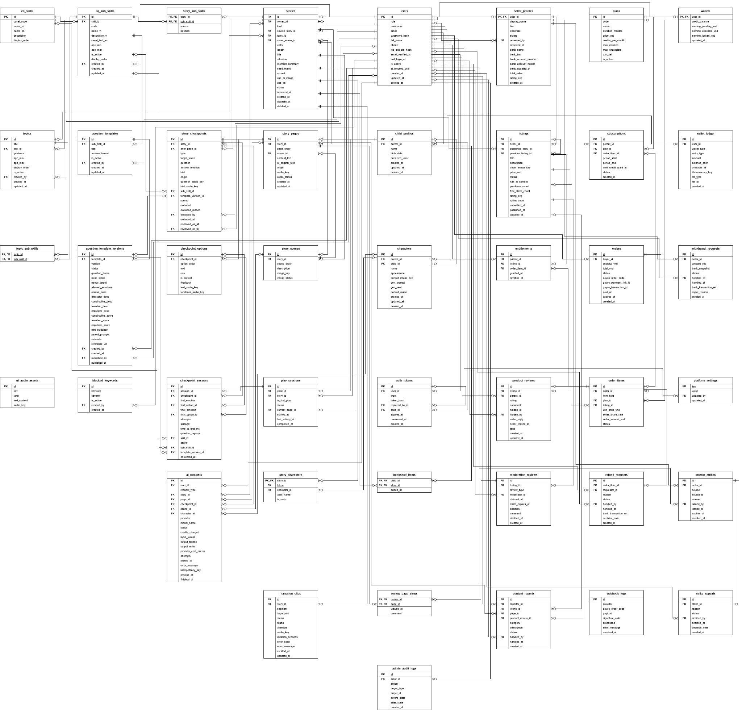
Entities Description
# | Entity | Description
1 | users | Accounts of parents, specialists and admins: credentials, role, kid exit PIN hash, AI block until.
2 | auth_tokens | Hashed refresh, email verification, password reset and kid session tokens.
3 | child_profiles | Children of a parent: name, birth date, preferred voice (the child's appearance is kept on their representative character).
4 | characters | Family characters with text-only appearance and optional AI portrait; at most one per child.
5 | eq_skills | The five CASEL competencies.
6 | eq_sub_skills | Standard CASEL sub-skill catalogue (casel_text_en kept for traceability); Specialists adjust but never add or delete.
7 | question_templates | Question template identity per sub-skill.
8 | question_template_versions | Draft / published versions with question, options and scores.
9 | topics | Lessons (competency, age range) managed by specialists.
10 | topic_sub_skills | Link of a topic to its 1–3 sub-skills.
11 | ui_audio_assets | Shared UI audio (emotion names, prompts) for Kid Mode.
12 | blocked_keywords | Blocked / warning keywords.
13 | stories | Private stories and published copies: length, status, situation, review time, options.
014 | story_sub_skills | 1–2 sub-skills practised by a family story (position 1 = main).
15 | story_characters | Characters of a story with {NVx} token; character_id for private, alias_name for published.
16 | story_scenes | Up to 4 scenes per story with image status and key.
17 | story_pages | Pages with tokenized text and content origin.
18 | story_checkpoints | Checkpoints after a page: type, sub-skill, template version, scored / excluded flags.
19 | checkpoint_options | Options of a checkpoint (role, correct flag).
20 | narration_clips | Narration segments with fingerprint, audio key and status.
21 | bookshelf_items | Stories assigned to a child’s bookshelf.
22 | play_sessions | Reading sessions of a child (first play flag, progress, status).
23 | checkpoint_answers | Answers with first / final choice and snapshot of score, skill, sub-skill, template version.
24 | ai_requests | Every AI call: type, status, credits charged, idempotency key, error.
25 | seller_profiles | Seller application and profile, bank account, status, totals.
26 | listings | Published stories for sale: status, seller price (price_vnd), counters, cover image.
27 | entitlements | Right of a parent to read a listing (revocable).
28 | product_reviews | Ratings, comments and tags of buyers, one seller reply, hidden flag.
29 | plans | Subscription plans: price, duration, credits per month, limits, can sell.
30 | subscriptions | Plan periods of a parent with next credit grant time.
31 | orders | Payment orders (payOS order code, status, expiry).
32 | order_items | Plan or listing item with price and seller share snapshot.
33 | refund_requests | Refund requests and admin decisions.
34 | webhook_logs | Raw payOS webhook calls with signature result.
35 | wallets | Credit and earning balances of a user.
36 | wallet_ledger | Append-only ledger of all balance changes.
37 | withdrawal_requests | Seller withdrawals and payout references.
38 | platform_settings | Key / value settings editable by Admin.
39 | moderation_reviews | Submission, follow-up and random audit reviews.
40 | review_page_views | Pages viewed by the specialist during a review.
41 | content_reports | Reports on listings or reviews.
42 | creator_strikes | Strikes issued to sellers with expiry.
43 | strike_appeals | Appeals against strikes.
44 | admin_audit_logs | Audit trail of Admin / Specialist actions.

3.2 Account & Family Profile

3.2.1 Register Account & Verify Email
Function trigger: A new parent submits the Register form; the parent opens the verification banner or Settings.
Function description: Creates a parent account with its credit and earning wallets and an active Free plan subscription, signs the user in and emails a verification code that the parent pastes into the Verify Email dialog.
Actor/roles: Parent
Purpose: Let new families start with the Free quota and confirm that they own the email.
Interface: Register screen; Verify Email Dialog (Parent Layout banner, Settings).
Data processing:
- Input data: fullName, username (3–50), email, phone (optional), password (≥ 8), confirm password; verification code.
- Output data: User profile with access / refresh tokens; email verified flag.
Function details:
- Business rules:
  - BR-01: Email and username are unique.
  - BR-02: Every new parent receives the Free plan through ensureFreeSubscription; credits come only from plans.
  - BR-03: The verification code is one-time and valid for 24 hours; resending requires sign-in and is allowed once every 60 seconds.
- Normal case:
  - The parent fills the form and submits.
  - System validates the input and uniqueness.
  - System creates users, wallets, Free subscription and the credit_grant ledger row in one transaction.
  - System emails the code and opens the Parent portal.
  - Parent pastes the code; system marks the email verified.
- Abnormal case:
  - AC-01: Email already registered → 409.
  - AC-02: Username already taken → 409.
  - AC-03: Invalid field → 400 with field errors.
  - AC-04: Code wrong, used or expired → 400.
  - AC-05: Resend within 60 s → 429 with the waiting time.
  - AC-06: Email already verified → 400.
Screen layout:
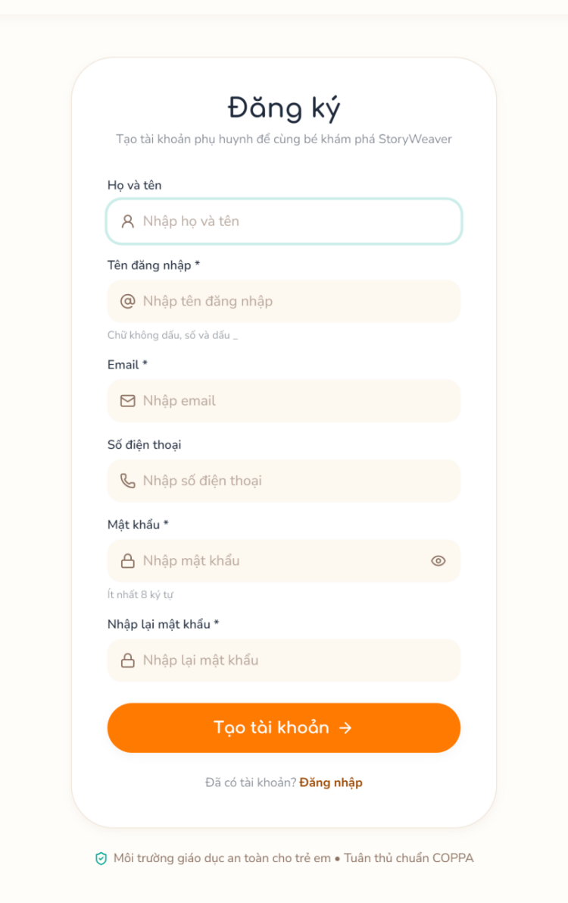
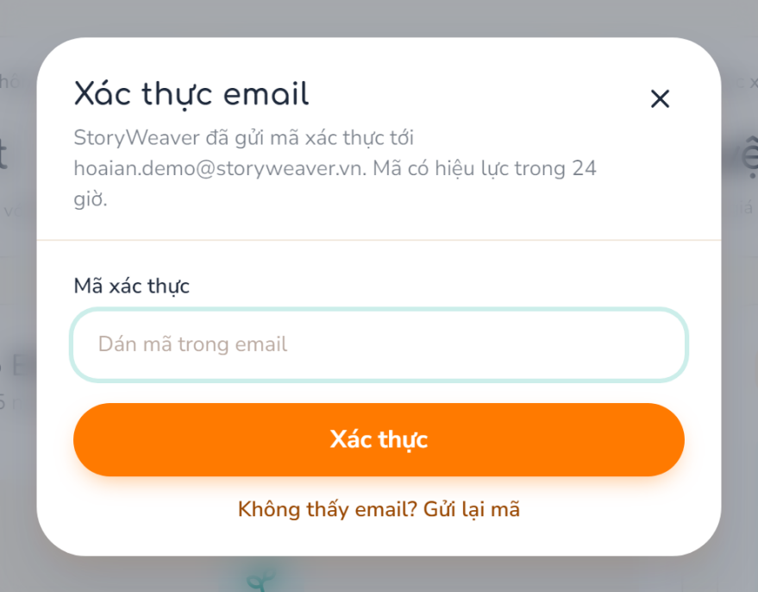

3.2.2 Login, Logout & Recover Password
Function trigger: User submits the Login form, clicks Log out, opens “Forgot password?” or change the password in Settings.
Function description: Authenticates with email or username and password, issues a JWT access token and a rotating refresh token; recovers access with an emailed code; changes the password while signed in.
Actor/roles: Parent, Specialist, Admin
Purpose: Secure, role-based access to the portals.
Interface: Login screen; Forgot Password Dialog; Settings (change password).
Data processing:
- Input data: emailOrUsername, password; refreshToken; email, recovery code, new password; current and new password.
- Output data: User profile with role, tokens; redirect to the role portal; password changed.
Function details:
- Business rules:
  - BR-04: Refresh tokens are stored hashed and rotated on every use; a used or expired token cannot be reused.
  - BR-05: Locked accounts cannot sign in.
  - BR-06: Recovery codes are one-time and expire 1 hour after they are issued; requesting a new code voids any unused one; the new password must differ from the current one.
- Normal case:
  - User enters credentials.
  - System verifies the password hash, issues tokens and redirects by role.
  - For recovery, the user requests a code, enters it with the new password and the system updates the password.
- Abnormal case:
  - AC-01: Wrong credentials → 401.
  - AC-02: Account locked → 403.
  - AC-03: Refresh token expired or reused → 401.
  - AC-04: Recovery code wrong, used or expired → 400.
Screen layout:
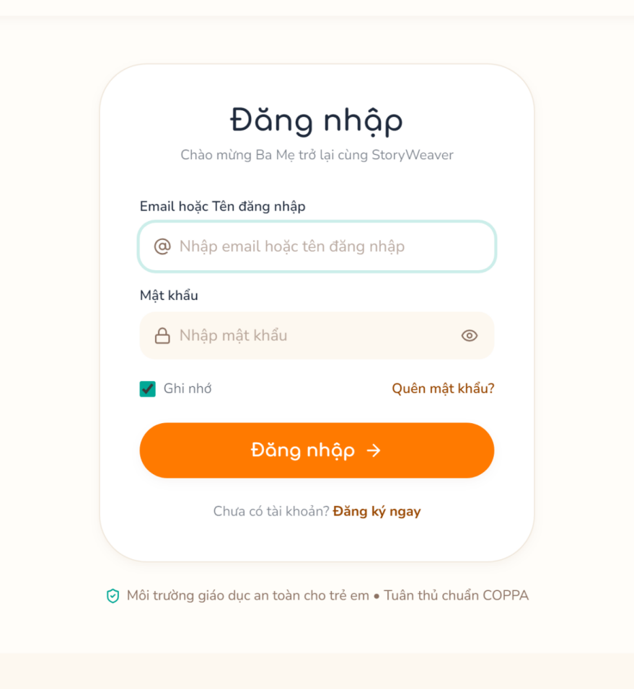
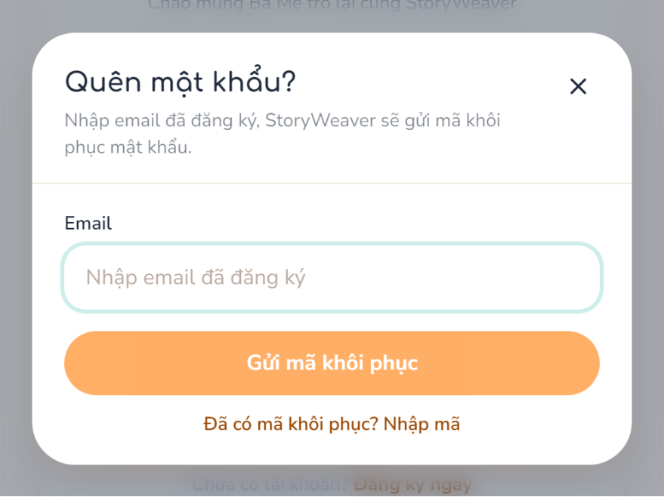

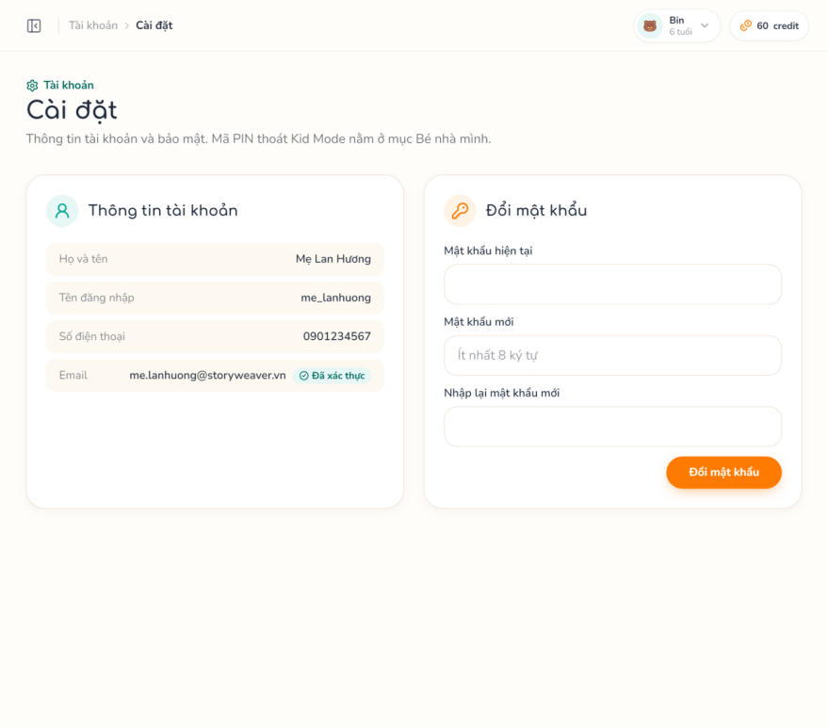

3.2.3 Manage Child Profile & Kid Pin
Function trigger: Parent opens My Children and clicks Add / Edit / Delete, or opens the Kid PIN card.
Function description: Creates, updates and soft-deletes child profiles and sets or changes the PIN that is required to leave Kid Mode.
Actor/roles: Parent
Purpose: Personalise stories and reports per child and keep children inside Kid Mode.
Interface: My Children; Child Form Modal; Delete Child Dialog; Kid PIN Modal.
Data processing:
- Input data: name, birthDate, preferredVoice, appearance (≤ 500); pin (4–6 digits); currentPin + newPin.
- Output data: Child list with reading settings; PIN saved as a hash.
Function details:
- Business rules:
  - BR-07: The number of children is limited by the current plan.
  - BR-08: Deleting a child is a soft delete.
  - BR-09: The Kid PIN has 4–6 digits and is stored hashed; it is set once and then changed with the current PIN.
- Normal case:
  - Parent opens the form and enters data.
  - System checks the plan quota and saves the profile.
  - Parent sets the PIN in the Kid PIN Modal.
- Abnormal case:
  - AC-01: Plan limit reached → 403.
  - AC-02: Child of another parent → 404.
  - AC-03: PIN already set (use change) → 400.
  - AC-04: Current PIN incorrect → 400.
Screen layout:
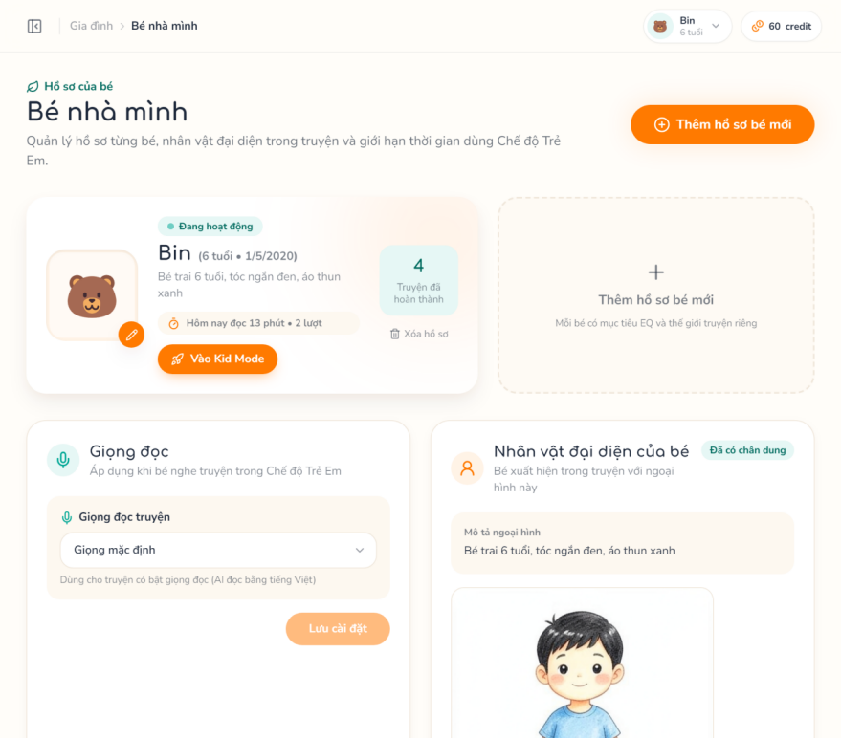
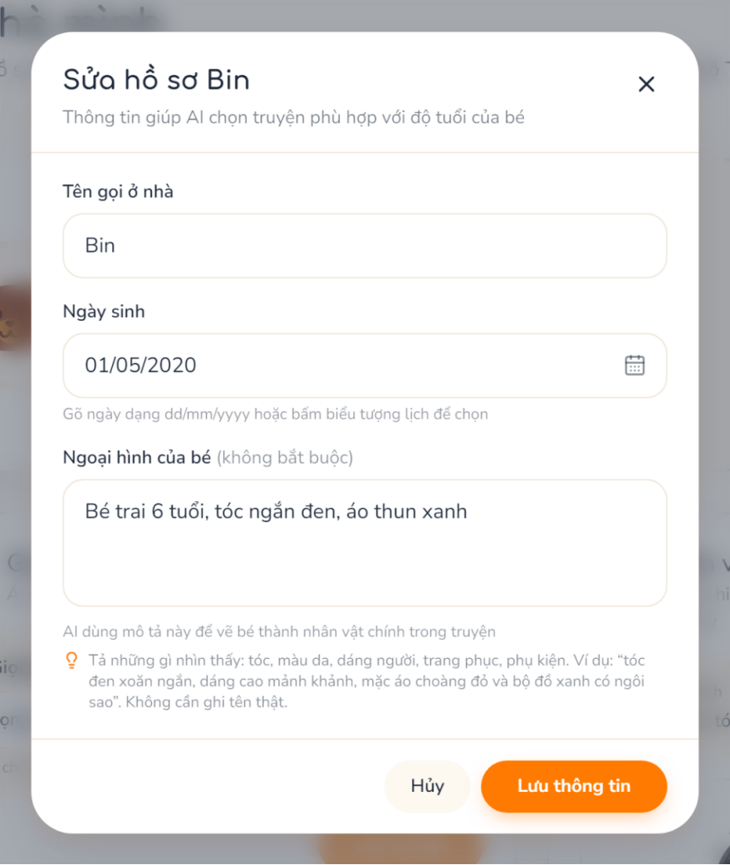
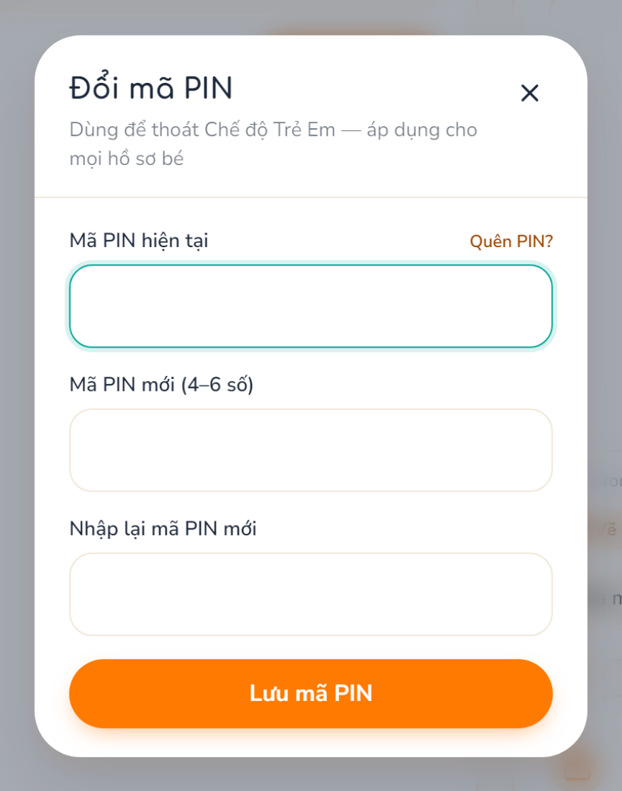

3.2.4 Manage Family Characters & AI Portrait
Function trigger: Parent opens Family Characters, adds a character or clicks “Create portrait”.
Function description: Manages characters described by text only and generates one AI portrait per character, used as the reference for scene illustrations.
Actor/roles: Parent
Purpose: Let stories feature the real family without photo uploads.
Interface: Family Characters; Character Form Modal; Delete Character Dialog.
Data processing:
- Input data: name, appearance, childId (optional); characterId for the portrait.
- Output data: Character list; portrait job status and image.
Function details:
- Business rules:
  - BR-10: Each child has at most one representative character (characters.child_id unique).
  - BR-11: The portrait prompt uses the appearance only, never the real name, and costs ai_cost.character_portrait credits (hold → consume / release).
  - BR-12: The number of characters is limited by the plan.
- Normal case:
  - Parent enters the name and appearance.
  - System saves the character.
  - Parent clicks Create portrait; system holds credits and queues the job.
  - Worker stores the portrait and consumes the credits.
- Abnormal case:
  - AC-01: Child already has a character → 409.
  - AC-02: No appearance description → 422.
  - AC-03: Portrait already being drawn → 409.
  - AC-04: Not enough credit → 402.
  - AC-05: Plan limit reached → 403.
Screen layout:
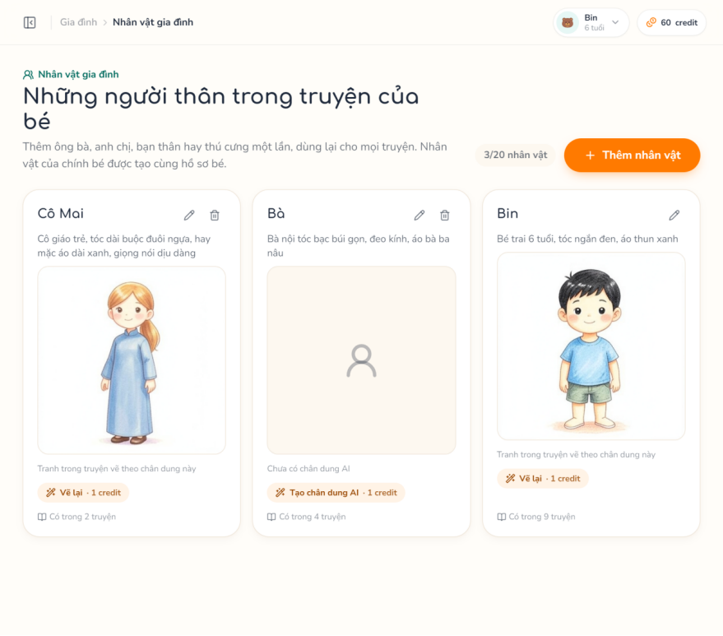
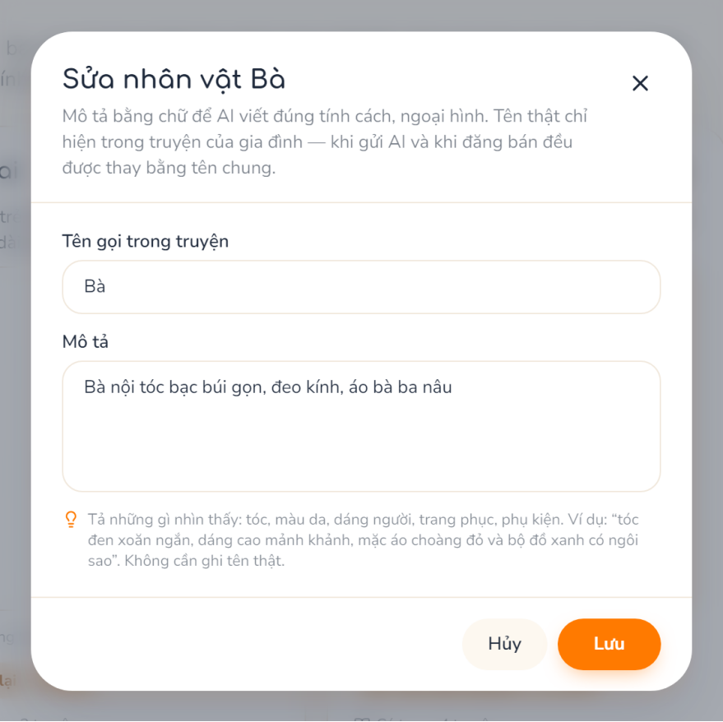

3.3 Story Creation & AI Assistance

3.3.1 Create Story
Function trigger: Parent clicks “Create story” in Story Studio and chooses an entry.
Function description: Creates a private story through one of three entries: Family story (the parent tells what happened, the AI proposes the sub-skills to practise), Model story (a Specialist topic) or Handwritten. Names are stored as {NVx} tokens and the page / checkpoint skeleton follows the length layout and the published template versions.
Actor/roles: Parent
Purpose: Start a personalised story built on pedagogical templates.
Interface: Create Story; Story Analysis + Sub-skill Picker; Add Family Character Modal.
Data processing:
- Input data: entry (family / topic / handwritten), topicId, length (short / medium / long / custom), characters (one isMain), title, useTts, useAiImage; for family: situation (20–2,000 characters), subSkillIds (optional, 1–2), analysisToken, scored.
- Output data: Analysis result (moment summary, 1–2 sub-skills, analysisToken); story detail in draft status.
Function details:
- Business rules:
  - BR-13: Model story requires an active topic and does not accept a situation; Handwritten (custom length) may have no topic.
  - BR-14: Family story requires an analysis made within 2 hours for the same owner, the same tokenised story and the same characters (analysisToken).
  - BR-15: The analysis is synchronous, costs no credit, is limited by limits.story_analysis_per_day (default 30) and only chooses sub-skills that have a published template version; the AI never sets scores or answers.
  - BR-16: A family story keeps 1–2 sub-skills (position 1 = main) in story_sub_skills; scored = false means “just tell the story” with reflection questions only.
  - BR-17: Real names in the situation are replaced by tokens before storage or any AI call.
- Normal case:
  - Parent chooses an entry.
  - For Family: parent tells the story and clicks “See what my child will practise”; system tokenises the text and calls the AI; parent confirms or changes the sub-skills.
  - Parent selects characters, length and story info.
  - System builds the skeleton and opens the Story Editor.
- Abnormal case:
  - AC-01: Model story without topic or with a situation → 422.
  - AC-02: Topic retired → 400.
  - AC-03: Analysis expired or story / characters changed → 422, analyse again.
  - AC-04: Daily analysis limit reached → 429.
  - AC-05: No usable sub-skill → 422.
  - AC-06: Blocked keyword in the situation → 422 with marked places.
  - AC-07: AI usage blocked → 403; AI failed → 502.
Screen layout:
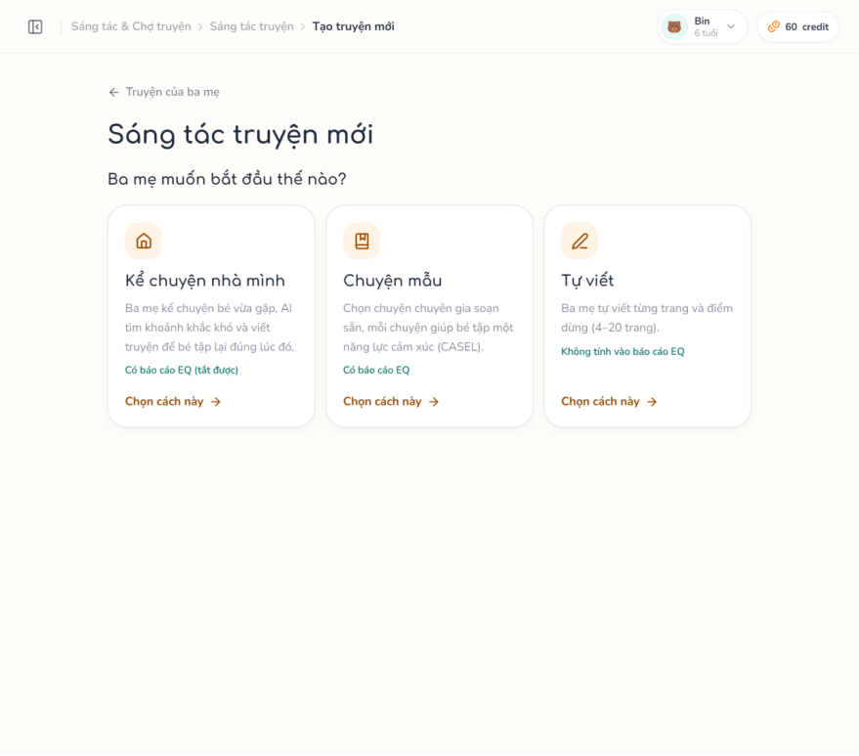

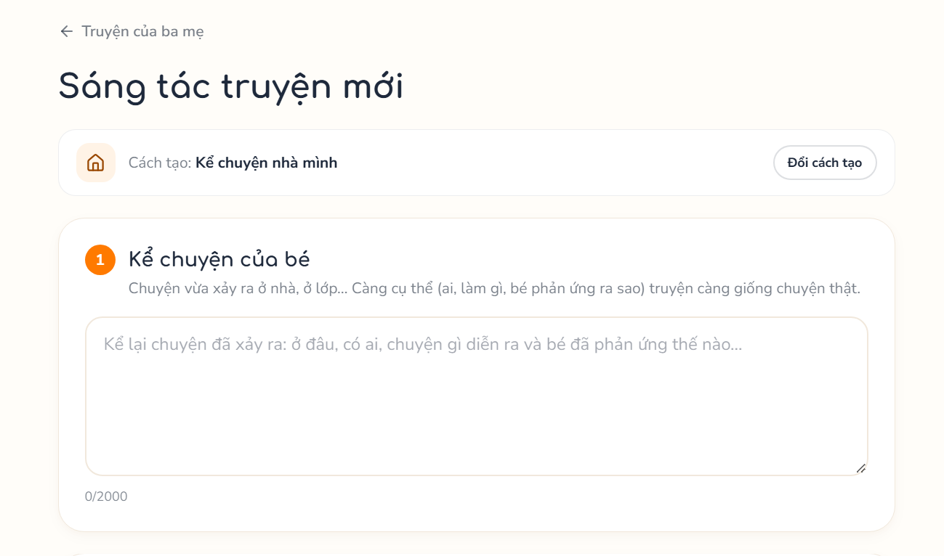
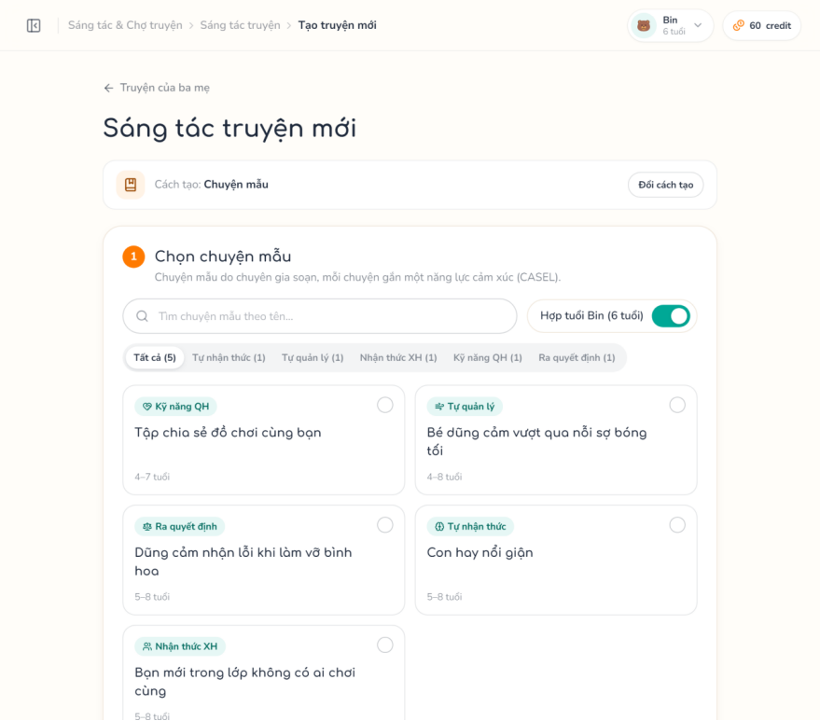
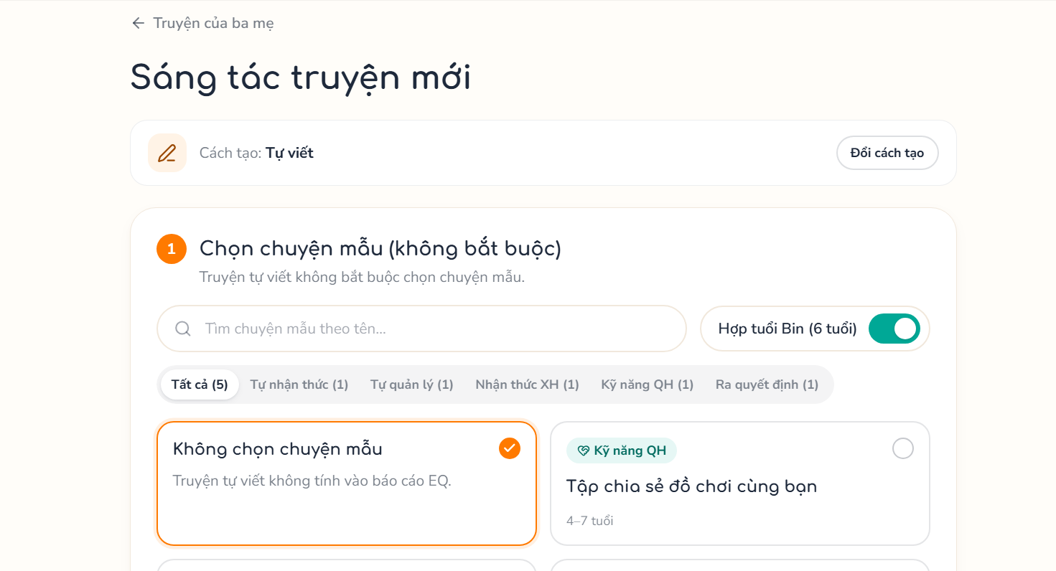
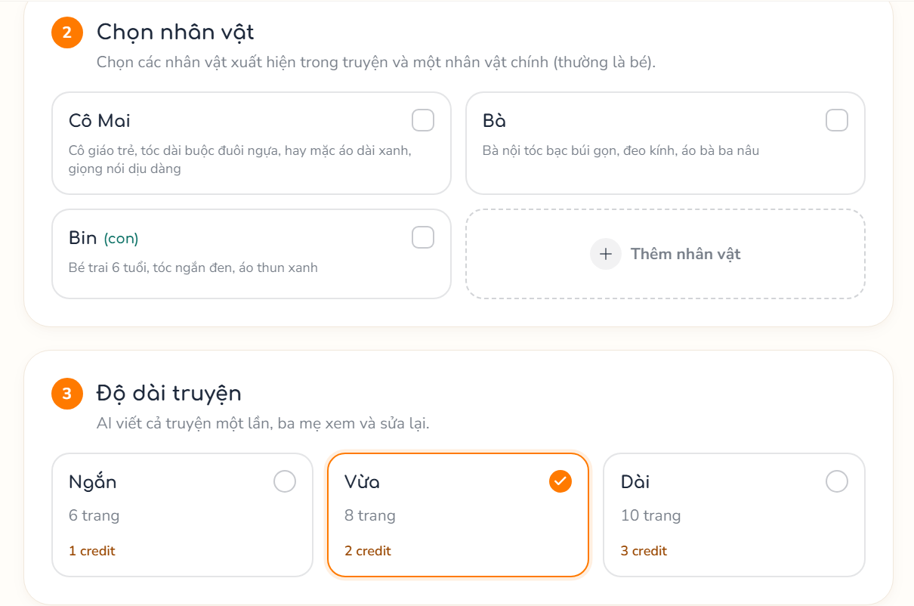
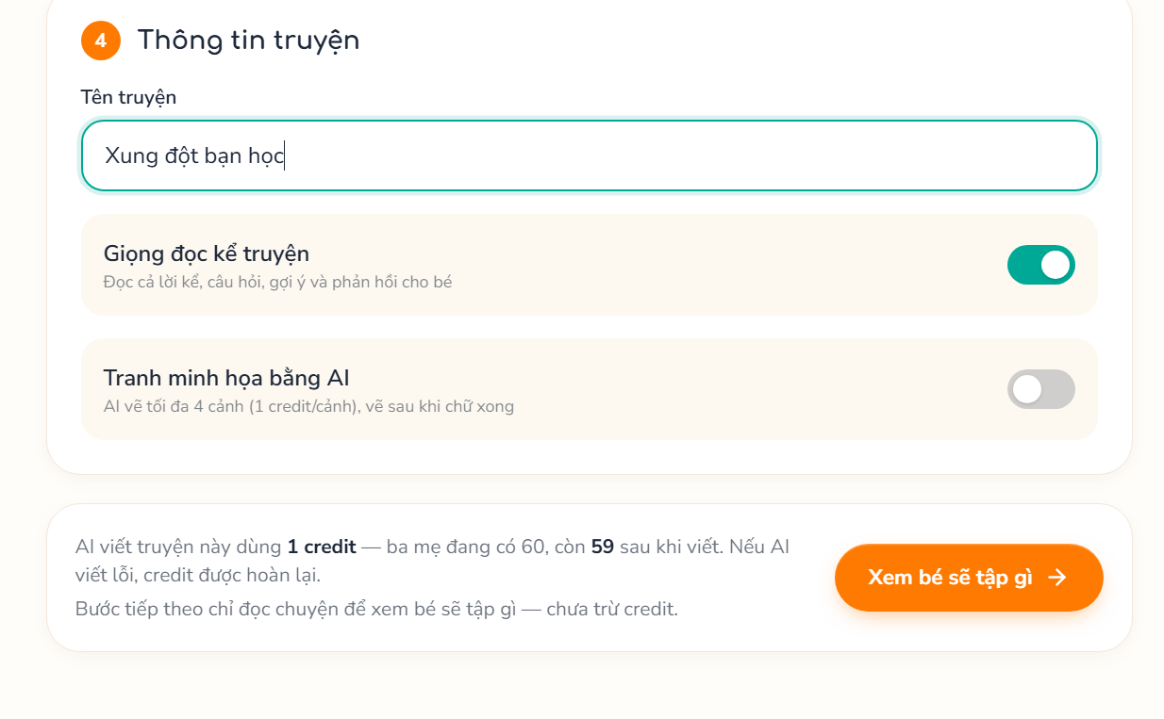

3.3.2 Write Story with AI & Edit Content
Function trigger: Parent clicks “Write with AI” or edits a page or checkpoint in the Story Editor.
Function description: Holds credits, records an ai_request and queues a job; the worker calls the AI service with tokens only and fills pages, scenes and checkpoints. The parent then edits page text; handwritten stories can also add and delete pages and checkpoints.
Actor/roles: Parent
Purpose: Draft a story in minutes while keeping the parent in control of the content.
Interface: Story Editor (AI progress, page editor, checkpoint editor).
Data processing:
- Input data: storyId; pageId + contentText; checkpoint fields (type, question, hint, answerEmotion, options).
- Output data: 202 with aiRequestId, then generation status (queued / processing / succeeded / failed); updated story with content origin ai_edited.
Function details:
- Business rules:
  - BR-18: Cost = ai_cost.story_text.<length> credits: hold on request, consume on success, release on failure.
  - BR-19: Handwritten stories cannot use AI writing; a story already played by a child cannot be regenerated; one generation at a time per story.
  - BR-20: A Specialist can temporarily block AI usage of a parent.
  - BR-21: Checkpoints of AI stories follow the Specialist templates and cannot be edited (422); handwritten stories have 4–20 pages and 0–6 checkpoints, which are never scored (a reflection may only be placed after the last page).
  - BR-22: The told story (situation) and the characters of a family story cannot be changed after creation (409).
- Normal case:
  - Parent clicks Write with AI.
  - System holds credits and queues the job.
  - Editor polls the generation status.
  - Worker persists the result; parent edits pages and saves.
- Abnormal case:
  - AC-01: Already generating → 409.
  - AC-02: Not enough credit → 402.
  - AC-03: Real name left in content → 422.
  - AC-04: AI blocked → 403.
  - AC-05: Queue unavailable → 503, credit released.
  - AC-06: AI failed or stale → failed status, credit released.
  - AC-07: Edit a checkpoint of an AI story → 422.
Screen layout:
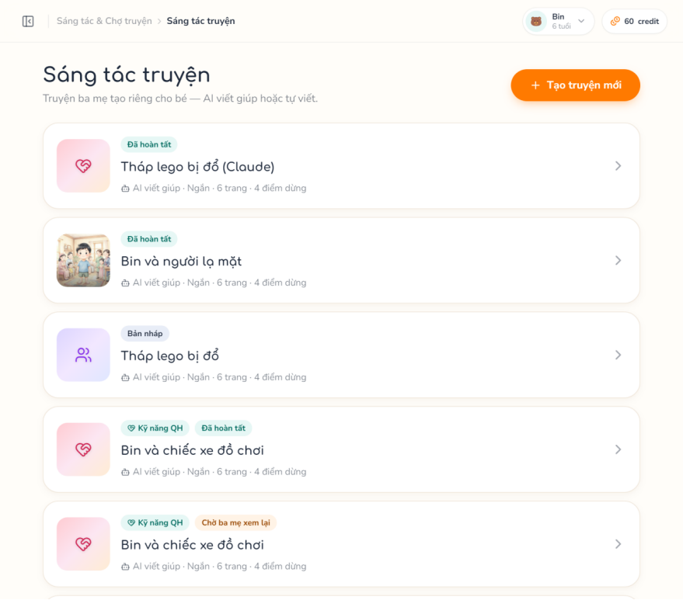
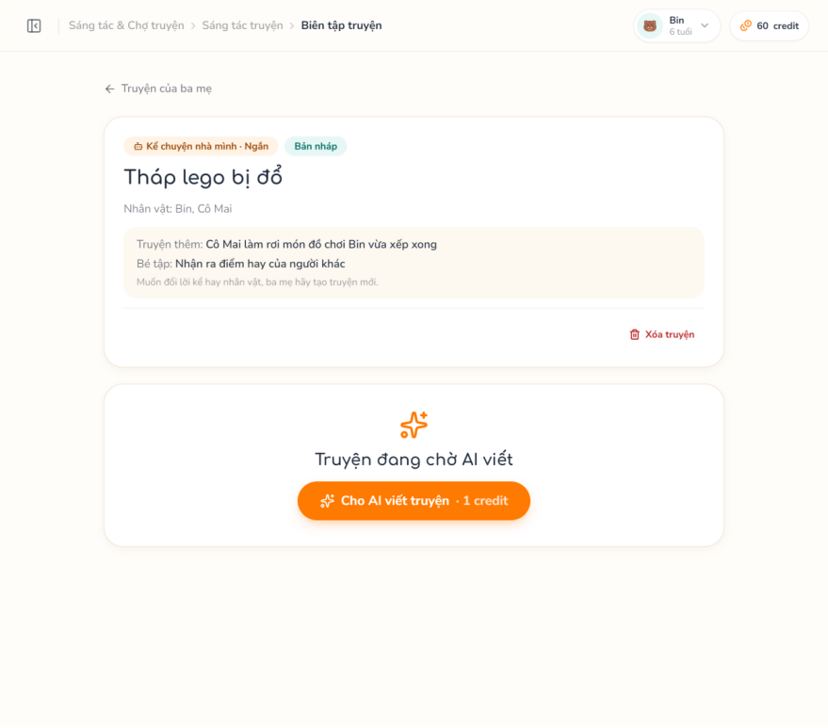
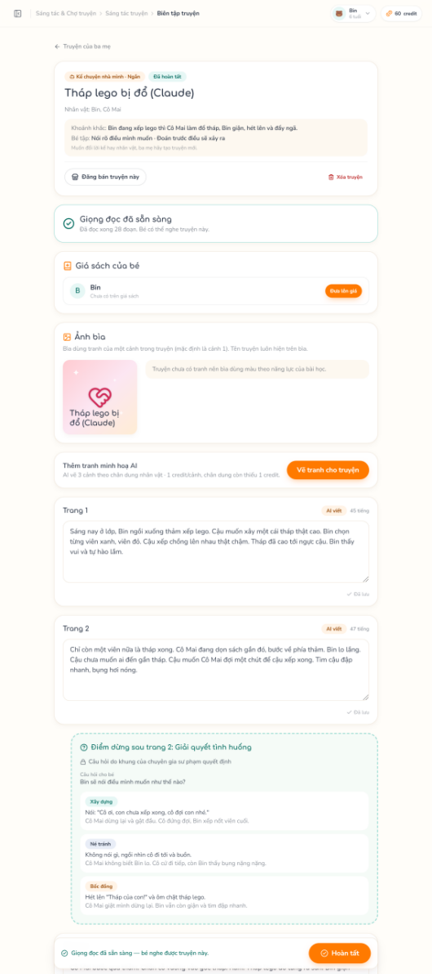

3.3.3 Generate AI Illustration & Choose Cover
Function trigger: Parent clicks “AI illustrations”, “Redraw” on a scene, or picks a cover scene.
Function description: Draws missing character portraits and up to 4 scene images (scenes wait for the portraits used as references) and lets the parent choose which illustrated scene is the cover.
Actor/roles: Parent
Purpose: Illustrate the story consistently with the family characters.
Interface: Story Editor (scenes, cover picker).
Data processing:
- Input data: storyId; sceneId for redraw or cover.
- Output data: Portrait / scene job status; image URLs; cover { imageUrl, competency }.
Function details:
- Business rules:
  - BR-23: ai_cost.character_portrait and ai_cost.scene_image credits, hold → consume / release.
  - BR-24: Image prompts use appearance descriptions only; there is no automatic image safety classifier, the reviewer decides.
  - BR-25: The cover is one scene with a ready image (default scene 1); without an image the web draws a cover in the competency colour.
- Normal case:
  - Parent requests images.
  - System queues portraits, then scenes.
  - Images appear in the editor; parent picks a cover.
- Abnormal case:
  - AC-01: Story generating → 409.
  - AC-02: Not enough credit → 402.
  - AC-03: Scene without description → 422.
  - AC-04: Scene already being drawn → 409.
  - AC-05: Cover scene without image → 422.
Screen layout:
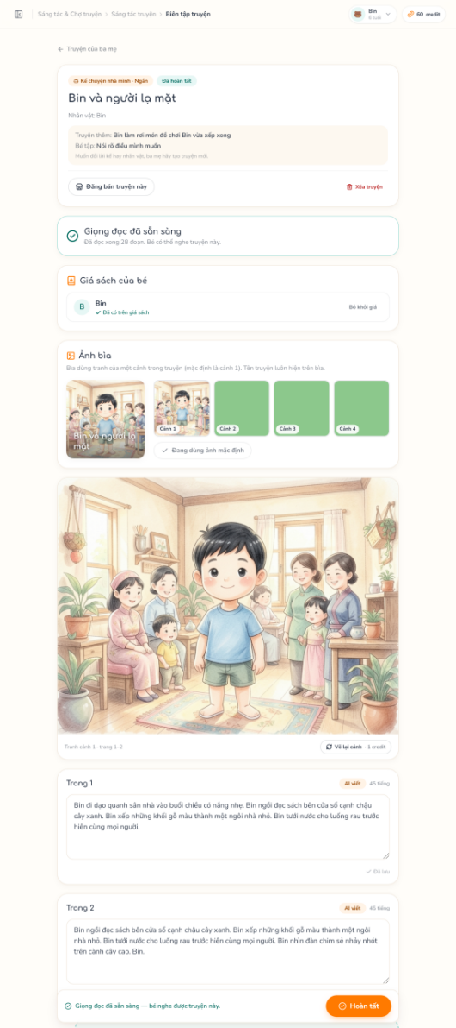

3.3.4 Review Story, Narration & Bookshelf
Function trigger: Parent clicks “Complete” after reading every page, retries narration or adds the story to a bookshelf.
Function description: Checks completeness and blocked keywords, marks the story reviewed and queues narration (VieNeu-TTS); ready stories can be added to or removed from a child’s bookshelf.
Actor/roles: Parent
Purpose: A human reviews every AI output before it reaches a child.
Interface: Story Editor (Narration + Cover + Bookshelf panels); Library.
Data processing:
- Input data: storyId; childId.
- Output data: Story with reviewedAt and narration progress; bookshelf list.
Function details:
- Business rules:
  - BR-26: All pages and checkpoints must be complete and free of blocked keywords before review.
  - BR-27: Narration costs no credit.
  - BR-28: A story is ready for a child only when it is reviewed, all narration clips are ready if narration is on, and (for a purchased story) its listing is not suspended or archived (loadReadiness); this gate applies to the bookshelf and to starting a play.
  - BR-29: Only stories the parent owns or holds an active entitlement for can be added.
- Normal case:
  - Parent reviews pages and clicks Complete.
  - System validates and queues narration.
  - Progress shows clips ready.
  - Parent adds the story to a child’s bookshelf.
- Abnormal case:
  - AC-01: Missing content → 422 with gaps.
  - AC-02: Blocked keyword → 422.
  - AC-03: TTS unavailable → 503, retry allowed.
  - AC-04: Story not ready → 422 with reason.
  - AC-05: Not owned → 404.
Screen layout:
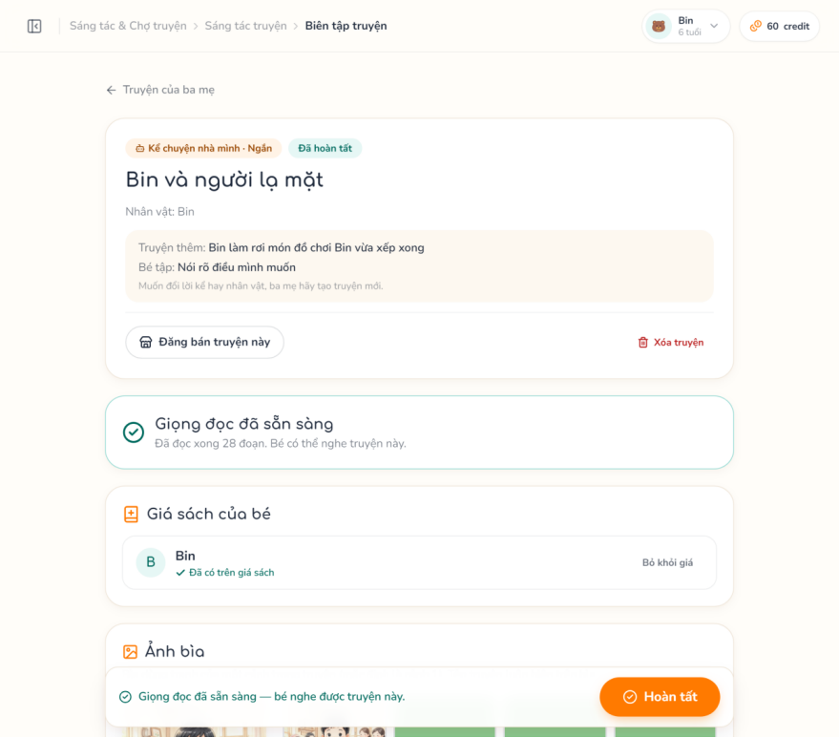
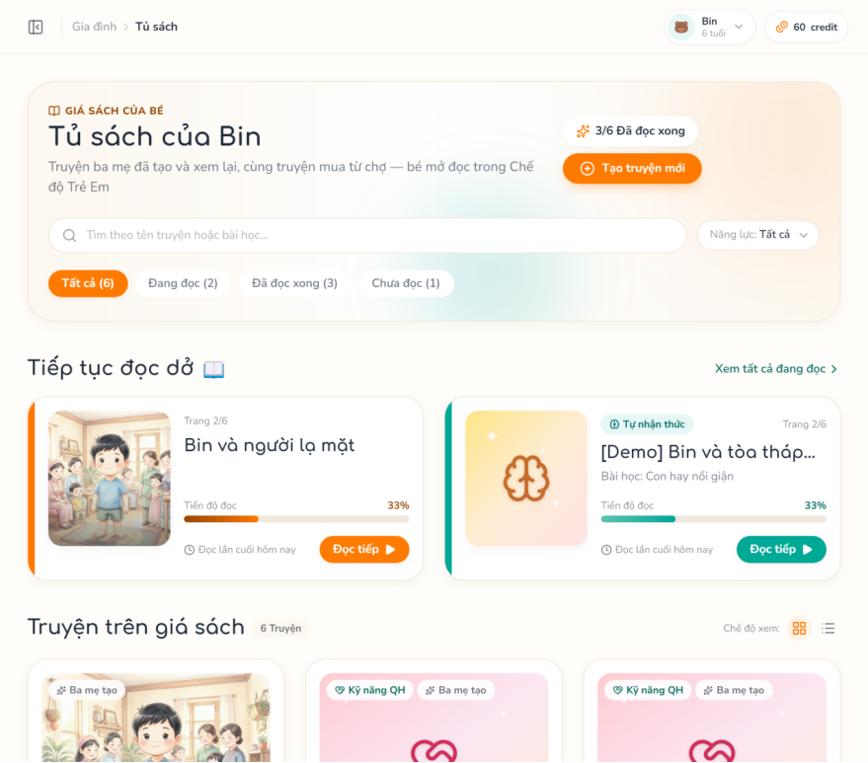

3.4 Pedagogical Content Library

3.4.1 Manage Sub-skills & Topics
Function trigger: Specialist opens Sub-skills or Model Stories (Topics).
Function description: Adjusts the fixed CASEL sub-skill catalogue (name, description, age range, on / off) and creates, edits or retires model stories attached to one competency and 1–3 sub-skills with a suggested plot.
Actor/roles: Specialist
Purpose: Define what checkpoints measure and what parents can start a model story from.
Interface: Sub-skills (Adjust Sub-skill Modal); Model Stories (Model Story Form Modal, Delete Dialog).
Data processing:
- Input data: Sub-skill: nameVi, descriptionVi, ageMin, ageMax, isActive. Topic: title, description, skillId, ageMin, ageMax, subSkillIds (1–3), guidance (≥ 10 characters).
- Output data: Sub-skill list with published template counts; topic list.
Function details:
- Business rules:
  - BR-30: Sub-skills are the standard CASEL items (casel_text_en kept for traceability); Specialists cannot add or delete them.
  - BR-31: ageMin ≤ ageMax, within 1–18.
  - BR-32: A topic has 1–3 sub-skills of its competency; a topic with stories keeps its competency and is retired instead of deleted.
- Normal case:
  - Specialist edits the fields and saves.
  - System validates and stores them.
- Abnormal case:
  - AC-01: Invalid age range → 400.
  - AC-02: Invalid competency or sub-skill → 400.
  - AC-03: Not found → 404.
Screen layout:
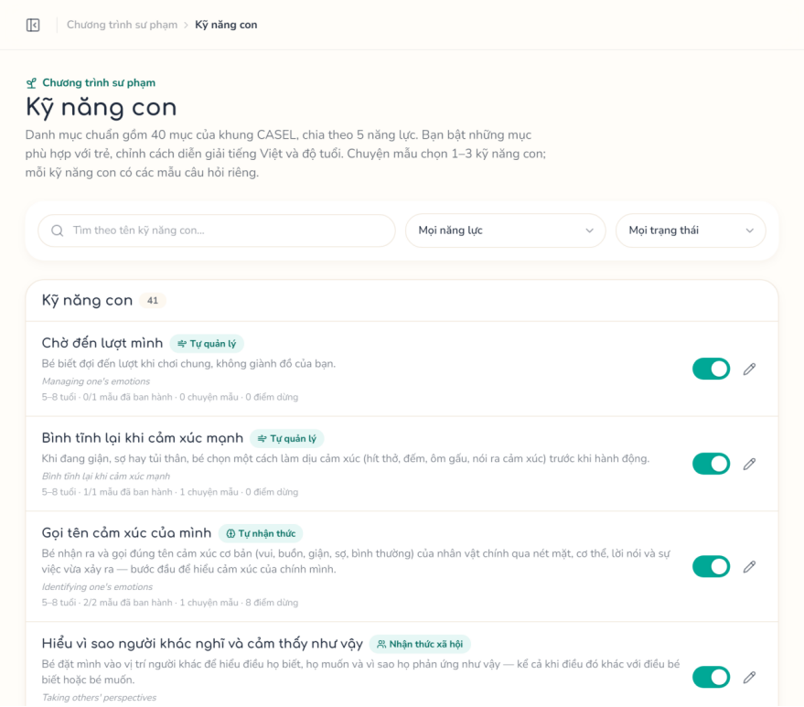
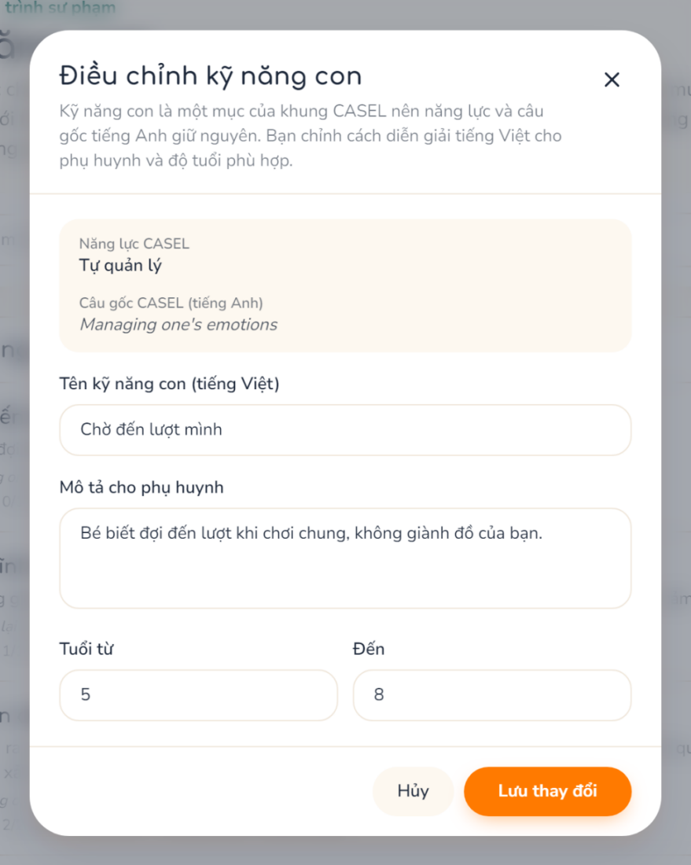
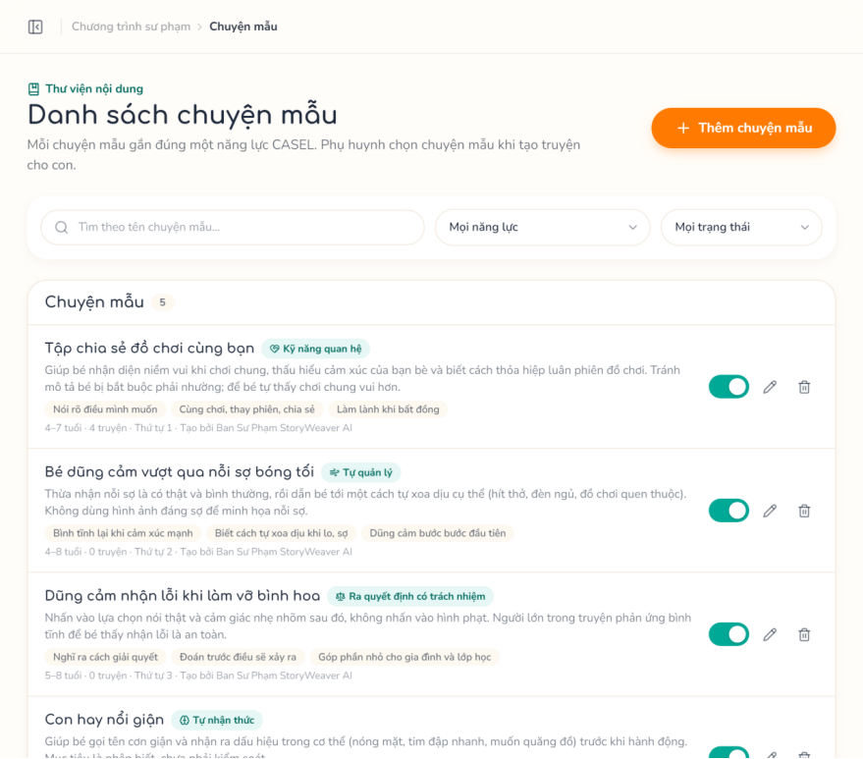
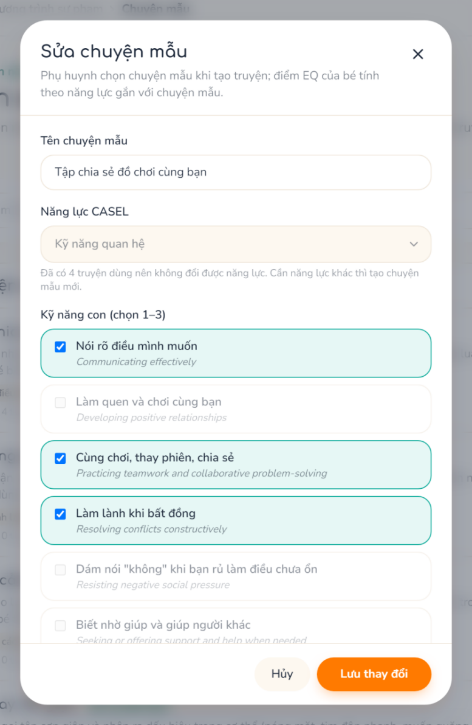

3.4.2 Manage Question Templates & Review Checkpoints
Function trigger: Specialist opens Question Templates or Checkpoint Review.
Function description: Creates templates per sub-skill, edits the draft, publishes it as a new version or duplicates the template; reviews checkpoints generated from templates (names masked), marking them OK or flagging them out of scoring.
Actor/roles: Specialist
Purpose: Standardise scored questions and keep EQ scoring based on valid questions.
Interface: Question Templates (Version Form, Delete Dialog); Checkpoint Review (Flag Question Modal).
Data processing:
- Input data: subSkillId, name; draft content (answer format, question, options, scores); checkpointId, reason.
- Output data: Templates with versions; review queue and statistics per template.
Function details:
- Business rules:
  - BR-33: At most one draft per template; a version can be published only when complete (assertVersionComplete).
  - BR-34: A template used by checkpoints can only be disabled, not deleted.
  - BR-35: Flagged checkpoints are not scored and are excluded from reports; marking OK restores them.
- Normal case:
  - Specialist creates or duplicates a template.
  - Edits and publishes the draft.
  - Reviews checkpoints and marks OK or flag.
- Abnormal case:
  - AC-01: Incomplete draft → 422.
  - AC-02: No draft or already published → 409.
  - AC-03: Template in use deleted → 409.
  - AC-04: Checkpoint not found → 404.
Screen layout:
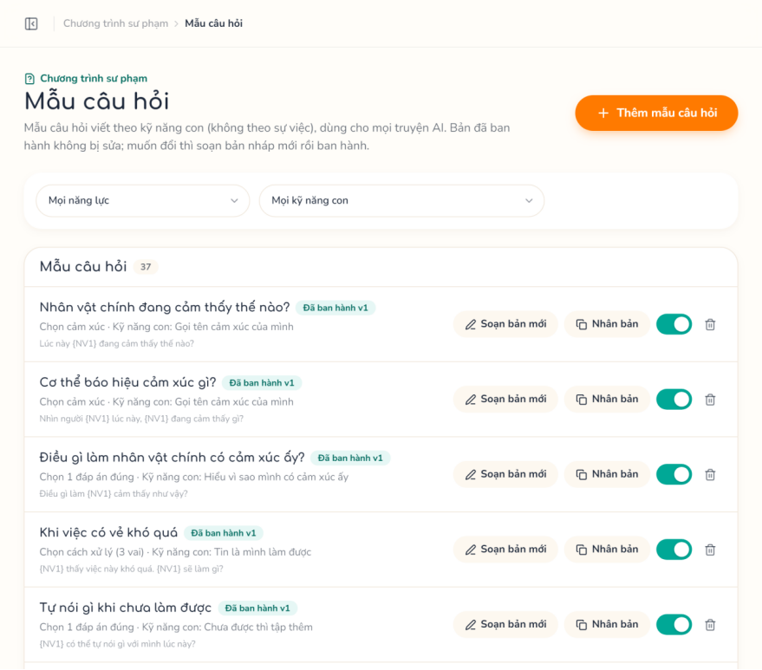
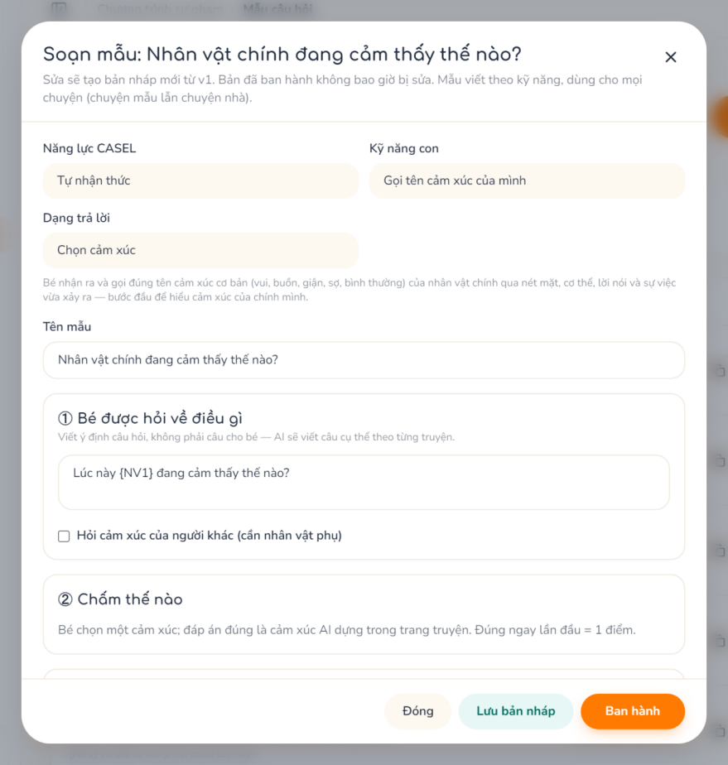
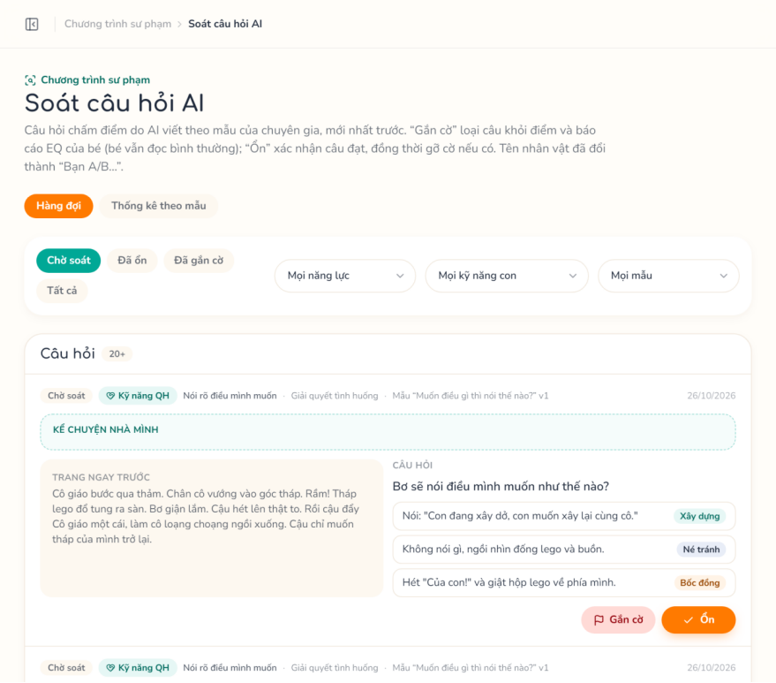

3.4.3 Configure Report Settings & Blocked Keywords
Function trigger: Specialist opens Report Settings or Blocked Keywords.
Function description: Edits the EQ report parameters and manages block / warn keywords applied to AI and parent-written text.
Actor/roles: Specialist
Purpose: Let experts tune the report and keep child-facing text safe.
Interface: Report Settings; Blocked Keywords (Delete Keyword Dialog).
Data processing:
- Input data: window, minAnswers, level thresholds; phrase, severity (block / warn), isActive.
- Output data: Saved settings; keyword list.
Function details:
- Business rules:
  - BR-36: Report defaults: last 5 answers, minimum 3, thresholds 0.5 and 0.8.
  - BR-37: Block stops both AI and parent-written text; warn only warns.
- Normal case:
  - Specialist edits values or keywords and saves.
- Abnormal case:
  - AC-01: Values outside the valid ranges → 400 (1 ≤ minAnswers ≤ window ≤ 20; 0 < developing threshold < secure threshold ≤ 1).
  - AC-02: Duplicate keyword → 409.
Screen layout:
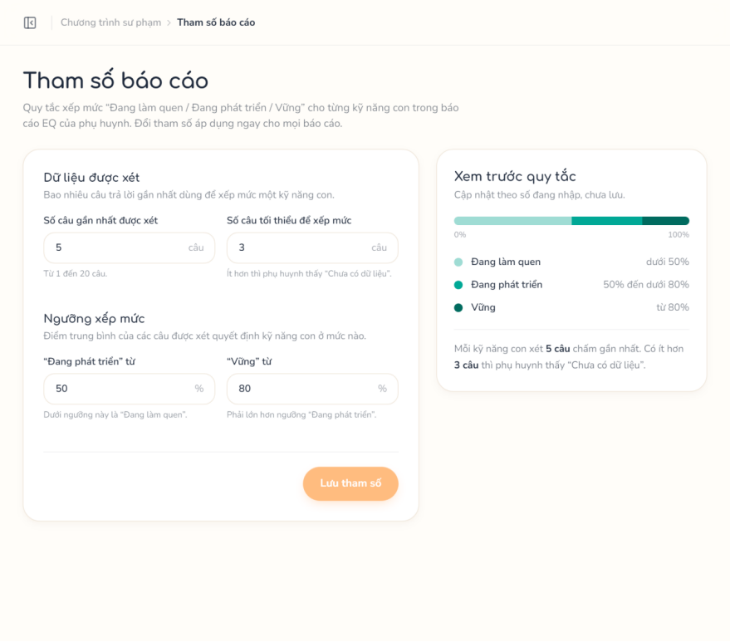
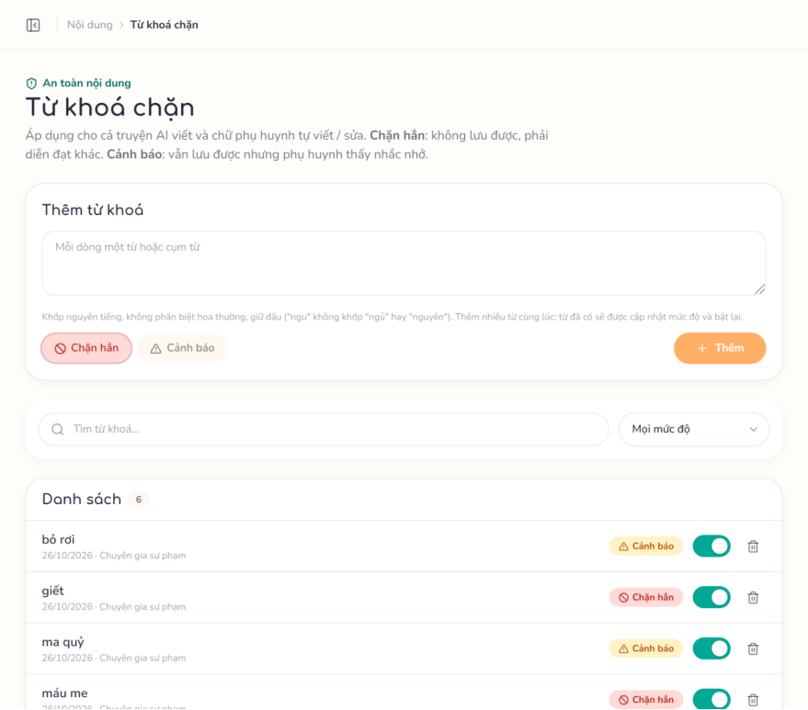

3.5 Kid Mode & EQ Report

3.5.1 Enter/Exit Kid Mode
Function trigger: Parent clicks “Enter Kid Mode” for a child; the child taps Exit and the parent enters the PIN.
Function description: Issues a scoped kid session token; leaving Kid Mode requires the parent PIN in the Parent Gate Dialog.
Actor/roles: Parent, Child
Purpose: Keep the child in a safe, zero-text space.
Interface: My Children → Kid Layout; Parent Gate Dialog.
Data processing:
- Input data: childId; pin.
- Output data: Kid session token; parent portal on exit.
Function details:
- Business rules:
  - BR-38: A PIN must be set before entering Kid Mode.
  - BR-39: The kid token is accepted only by /kid/* endpoints and carries only the child.
- Normal case:
  - Parent enters Kid Mode.
  - Child reads.
  - Parent types the PIN to exit.
- Abnormal case:
  - AC-01: No PIN → 403.
  - AC-02: Wrong PIN → 401.
  - AC-03: Session expired → 401.
Screen layout:
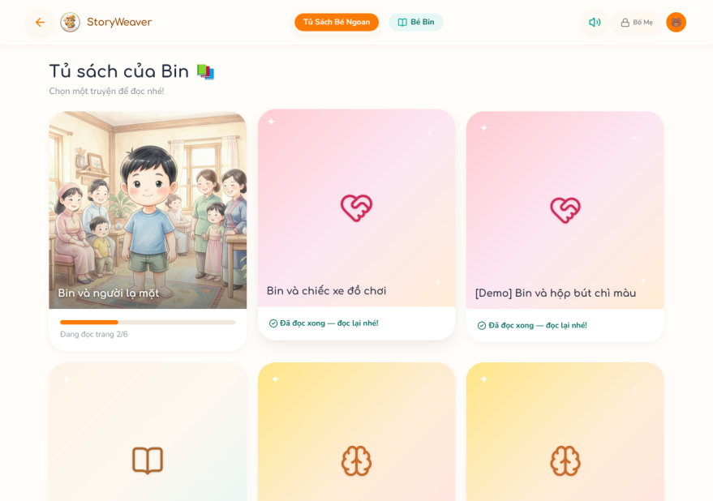
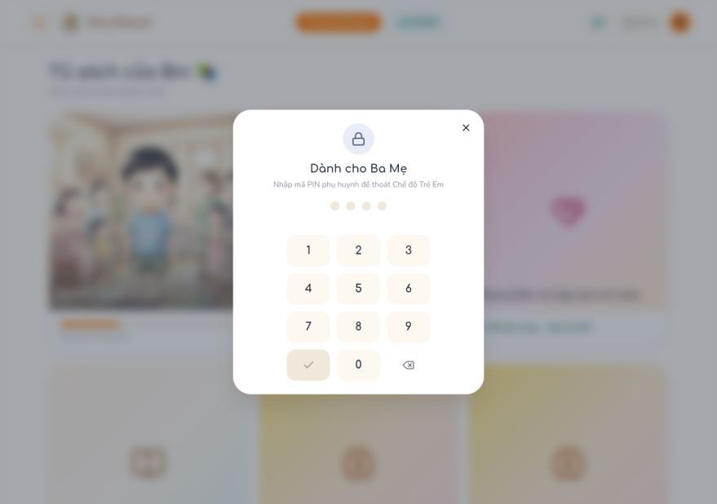

3.5.2 Read Story & Answer Checkpoint
Function trigger: Child taps a story on the Kid Bookshelf.
Function description: Starts or resumes a play session, plays narration page by page and records checkpoint answers scored on the server.
Actor/roles: Child
Purpose: Practise EQ through interactive stories.
Interface: Kid Bookshelf; Story Reader; Checkpoint Question; Story Complete Dialog.
Data processing:
- Input data: storyId; checkpointId + emotion | optionId, skipped, timeToFirstMs.
- Output data: Pages, audio, outcome (hint, correct answer audio); completion.
Function details:
- Business rules:
  - BR-40: Correct answers are never sent to the device.
  - BR-41: Only the first choice of the first play is scored; score, skill, sub-skill and template version are snapshotted into checkpoint_answers.
  - BR-42: Reflection, unscored, flagged, handwritten or template-less checkpoints have score null; a wrong template binding is not scored and is logged, never a 500 to the child.
  - BR-43: At emotion and perspective checkpoints a wrong first choice gives a hint and a second try, and a second wrong choice reveals the correct answer; problem-solving checkpoints give the feedback of the chosen option; reflection has no right or wrong answer and cannot be skipped.
- Normal case:
  - Start or resume the session.
  - Listen to pages.
  - Answer checkpoints.
  - Complete the story; read again or return to the bookshelf.
- Abnormal case:
  - AC-01: Story not ready → 422.
  - AC-02: Session finished → 409.
  - AC-03: Choice does not match the checkpoint type → 400.
Screen layout:
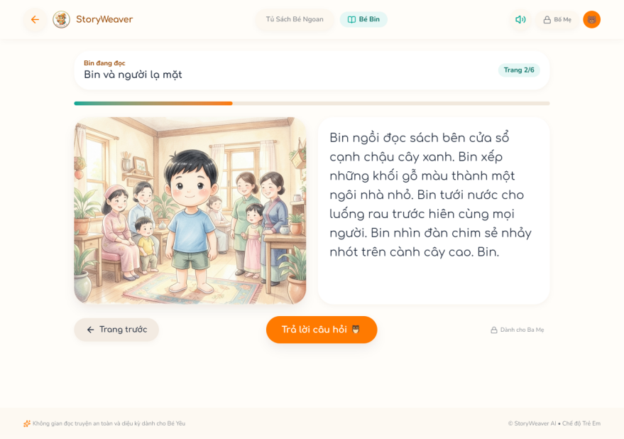
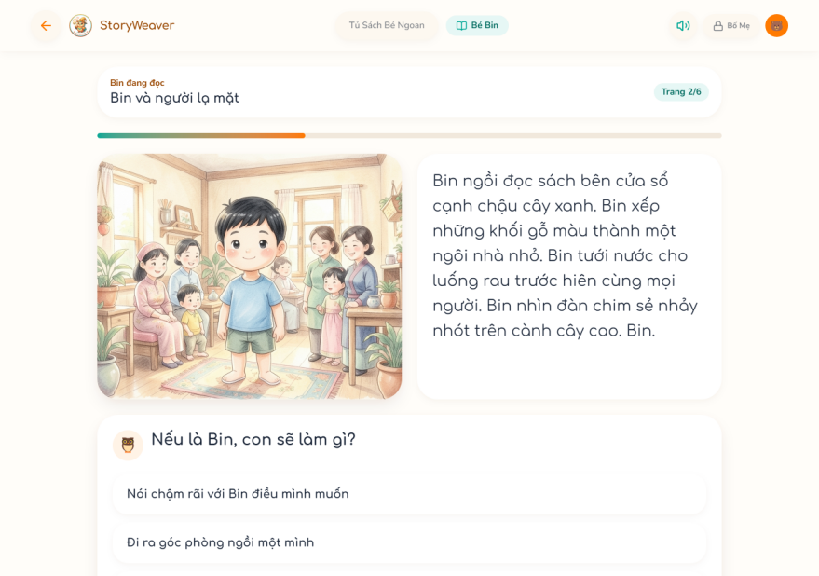

3.5.3 View EQ Report
Function trigger: Parent opens EQ Journey and selects a child.
Function description: Computes levels per sub-skill and competency from scored first-play answers, with evidence, conversation tips, weekly trend and suggested model stories.
Actor/roles: Parent
Purpose: Show the child’s emotional development.
Interface: EQ Journey; Sub-skill Evidence Modal.
Data processing:
- Input data: childId, weeks (4–26).
- Output data: Five CASEL competencies, sub-skill levels, evidence, suggestions.
Function details:
- Business rules:
  - BR-44: Level from the last N answers (minimum M) with the Specialist thresholds; competency level = lowest sub-skill level.
  - BR-45: Flagged checkpoints are ignored.
- Normal case:
  - Parent opens the report.
  - System computes and shows it.
- Abnormal case:
  - AC-01: Not enough data → empty level (no error).
  - AC-02: Child not owned → 404.
Screen layout:
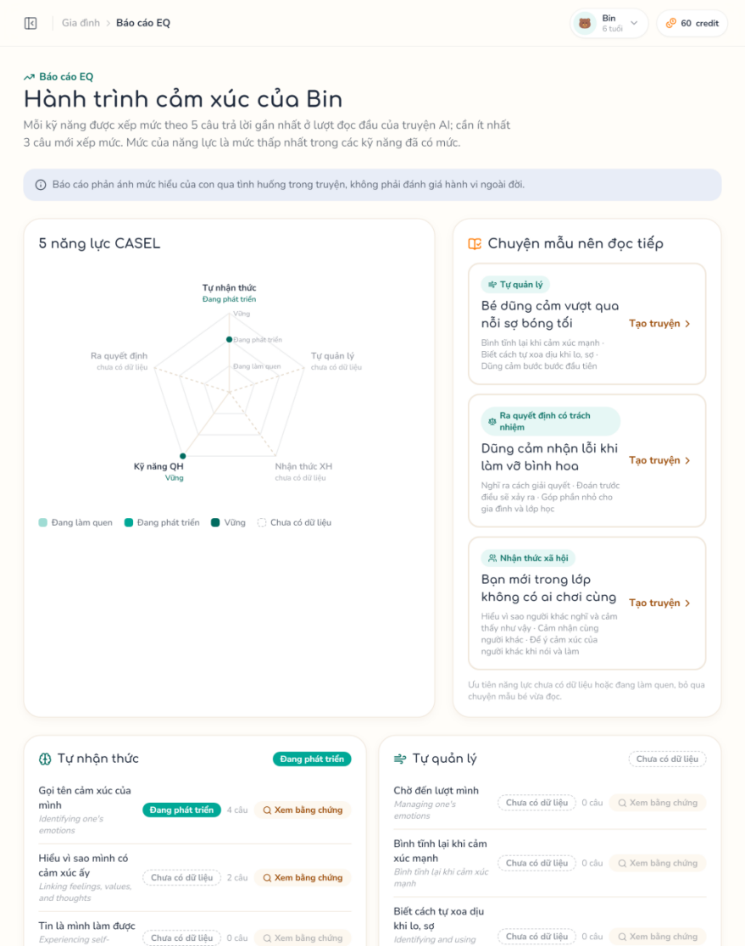

3.6 Subscription, Marketplace & Payment

3.6.1 Subscribe/Upgrade Plan
Function trigger: Parent chooses a plan on Plans & Credit; payOS calls the webhook after payment.
Function description: Creates a payOS order for the plan; the signed webhook fulfils the order and starts a new prepaid period with the monthly credit grant.
Actor/roles: Parent
Purpose: Provide AI credits and higher limits.
Interface: Plans & Credit → payOS Checkout → Billing Result; POST /payments/payos/webhook.
Data processing:
- Input data: planId; payOS webhook body.
- Output data: Order and checkoutUrl; active subscription with credits.
Function details:
- Business rules:
  - BR-46: Buying a different plan starts a new period at once: it closes the active one, keeps the remaining credits once and grants credits_per_month; buying the same plan again extends the current period; unused credits expire at the next monthly grant.
  - BR-47: Only fulfillOrder moves an order from pending | expired to paid, with a conditional update.
  - BR-48: The webhook is logged and fulfils only when the signature is valid, the code is 00 and the amount matches.
- Normal case:
  - Parent selects a plan.
  - Pays via PayOS.
  - Webhook fulfils the order.
  - Result page shows the new plan.
- Abnormal case:
  - AC-01: Plan inactive → 404.
  - AC-02: Cancelled or expired payment → order closed.
  - AC-03: Invalid signature → logged, not processed.
  - AC-04: Webhook replay → already processed.
Screen layout:
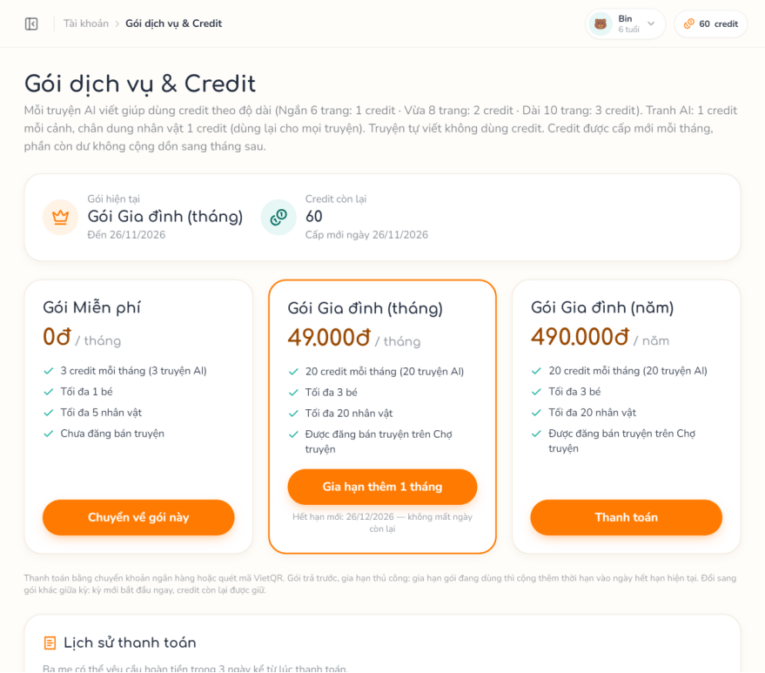
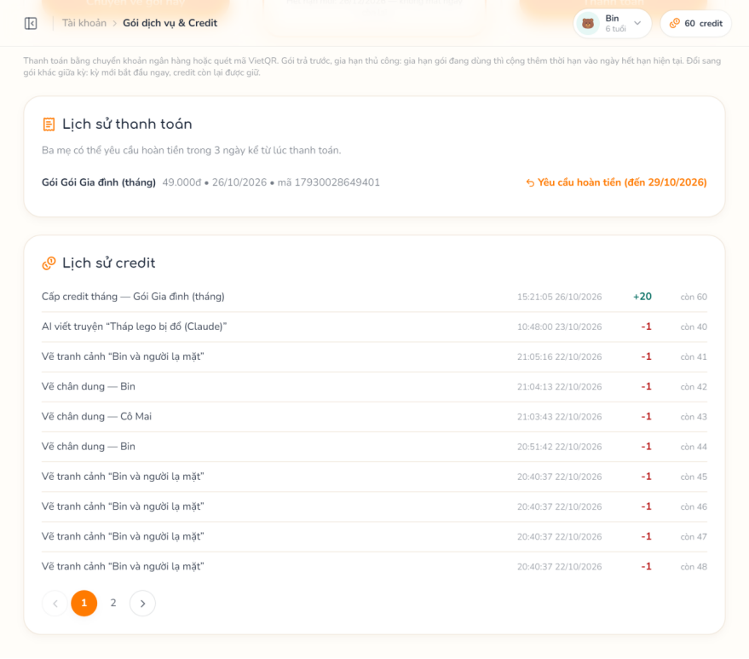

3.6.2 Browse & Buy Story
Function trigger: Parent opens Marketplace, a Listing Detail and clicks Buy or Get for free.
Function description: Lists published stories with search, filters and sorting; creates an order for a listing; free stories are delivered at once, paid ones through payOS.
Actor/roles: Parent
Purpose: Discover stories and get the right to read them.
Interface: Marketplace; Listing Detail; payOS Checkout → Purchase Result.
Data processing:
- Input data: search, competency, price range, narration, sort, page; listingId.
- Output data: Listings with price, rating and purchases; first page with generic names; entitlement after payment.
Function details:
- Business rules:
  - BR-49: Only published listings of approved sellers are shown.
  - BR-50: Price and seller share are snapshotted in order_items; a paid sale records the seller earning (market.seller_share_rate, default 80%) held for market.earning_hold_days.
  - BR-51: A duplicate purchase of an owned story opens a refund request automatically.
- Normal case:
  - Parent filters and opens a listing.
  - Clicks Buy and pays.
  - Webhook fulfils the order.
  - Story appears in the Library.
- Abnormal case:
  - AC-01: Own story → 422.
  - AC-02: Already owned → 409.
  - AC-03: Listing not available → 404.
  - AC-04: payOS unavailable → 503.
Screen layout:
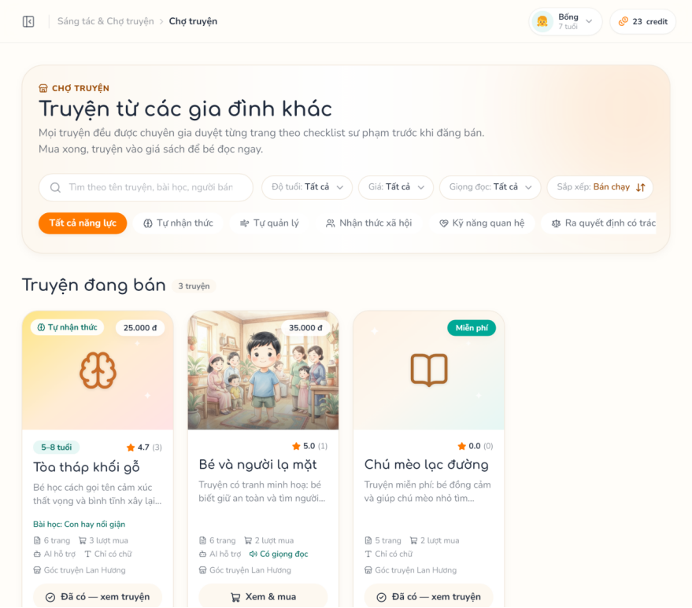
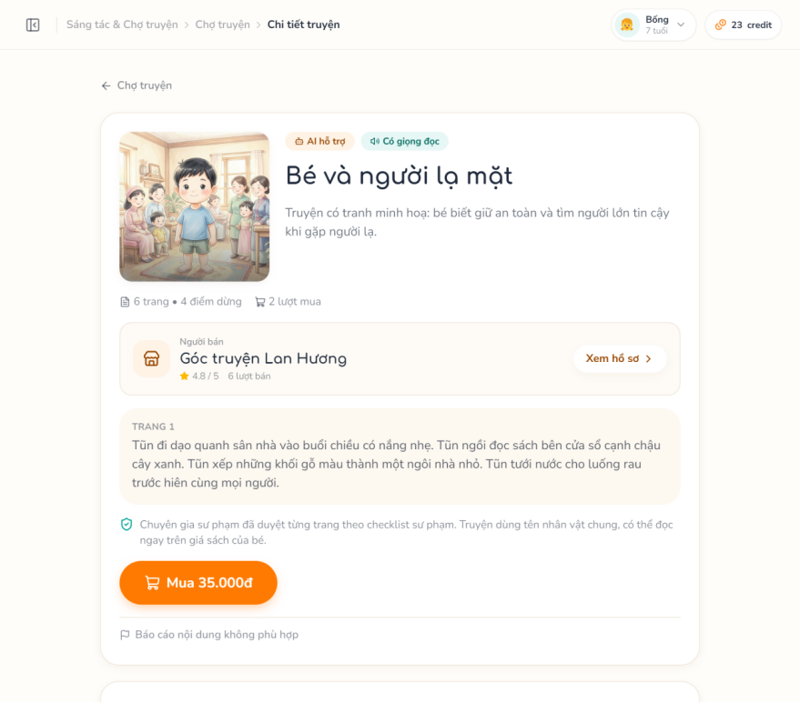

3.6.3 Rate & Review Story
Function trigger: Parent opens the reviews of a purchased story.
Function description: The buyer rates (1–5) with a comment and tags after the child finished the story; the seller replies once; users can report reviews.
Actor/roles: Parent
Purpose: Trustworthy feedback for other families.
Interface: Listing Detail (reviews); Report Story Dialog.
Data processing:
- Input data: rating, comment, tags (fixed list); reply; report category.
- Output data: Reviews with rating distribution.
Function details:
- Business rules:
  - BR-52: Only buyers whose child completed the story may review.
  - BR-53: One seller reply per review; a hidden review cannot be edited.
- Normal case:
  - Parent writes a review.
  - Seller replies.
- Abnormal case:
  - AC-01: Not owned or not finished → 422.
  - AC-02: Hidden review edited → 403.
  - AC-03: Already replied or reported → 409.
Screen layout:
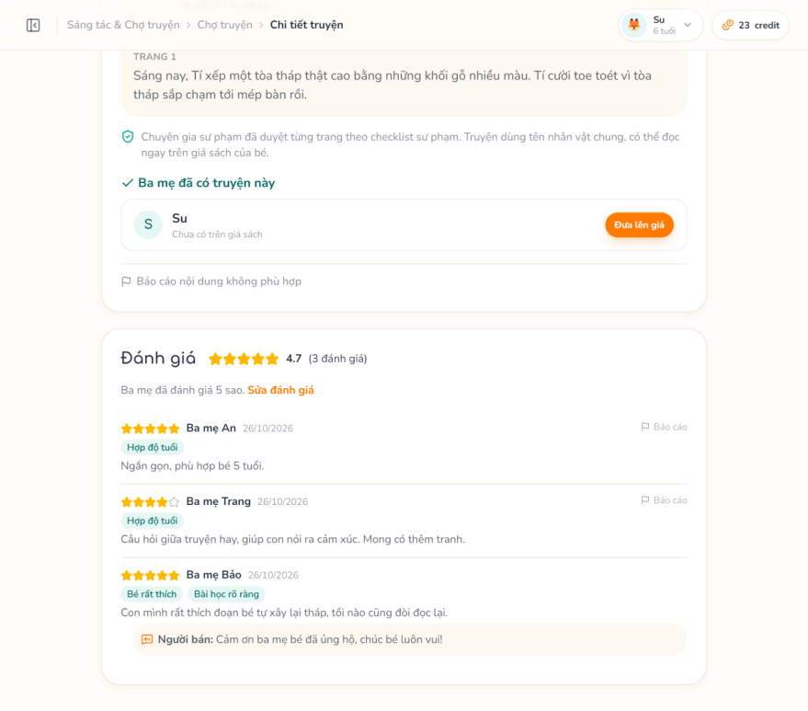

3.6.4 Request & Decide Refund
Function trigger: Parent opens the payment history and clicks Request refund; Admin opens Refunds.
Function description: The parent requests a refund for a paid item within the refund window; the Admin transfers the money and approves with the bank reference (revoking the entitlement or cancelling the subscription and reversing the seller earning) or rejects with a note.
Actor/roles: Parent, Admin
Purpose: Handle mistakes and complaints.
Interface: Plans & Credit (Refund Request Form); Admin Refunds.
Data processing:
- Input data: orderItemId, reason; refundId, approve, bankTransactionRef | note.
- Output data: Refund request pending → approved / rejected.
Function details:
- Business rules:
  - BR-54: Only a paid item with price > 0, requested within market.refund_window_days of payment (default 3 days; Admin sets 1–30, never more than market.earning_hold_days), with one request per item.
  - BR-55: Refunds are transferred manually by the Admin; if the seller has already withdrawn that earning, approval is refused (422) and the request stays pending to be settled with the seller.
- Normal case:
  - Parent submits the reason.
  - Admin transfers the money, enters the reference and approves.
- Abnormal case:
  - AC-01: Already requested → 409.
  - AC-02: Window expired or not paid → 422.
  - AC-03: Already processed → 409.
  - AC-04: Missing reference or note → 422.
Screen layout:
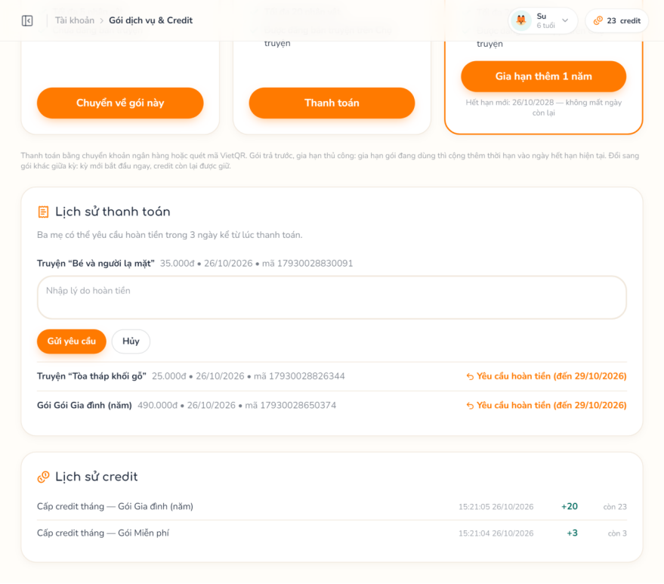
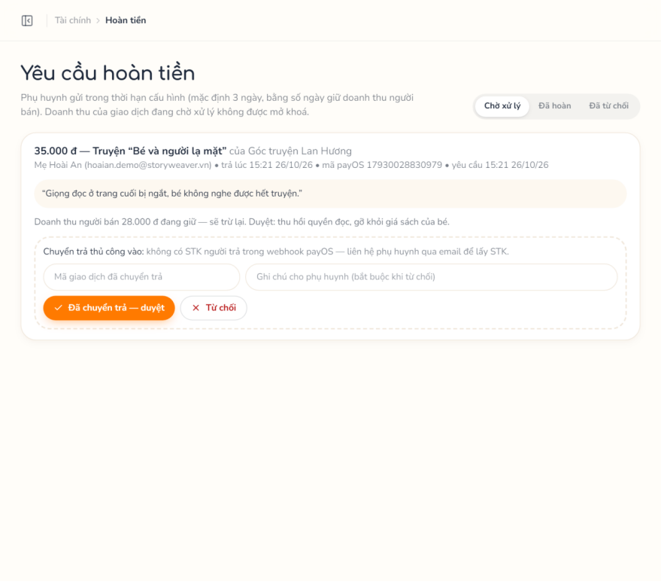

3.7 Selling & Moderation

3.7.1 Seller Onboarding
Function trigger: Parent clicks “Become a seller” on Selling; Specialist opens Seller Applications.
Function description: The parent submits a seller application; a Specialist approves or rejects it.
Actor/roles: Parent, Specialist
Purpose: Only vetted parents can sell stories.
Interface: Selling (Seller Application Form); Seller Applications.
Data processing:
- Input data: displayName (2–100), bio, expertise; userId, approve.
- Output data: Seller profile pending → approved / rejected.
Function details:
- Business rules:
  - BR-56: The plan must allow selling (can_sell).
  - BR-57: A rejected applicant may re-apply; a suspended seller cannot; only pending applications can be decided.
- Normal case:
  - Parent submits the form.
  - Specialist reads the profile and decides.
- Abnormal case:
  - AC-01: Plan does not allow selling → 422.
  - AC-02: Already seller or pending → 409.
  - AC-03: Seller suspended → 403.
  - AC-04: No pending application → 404.
Screen layout:
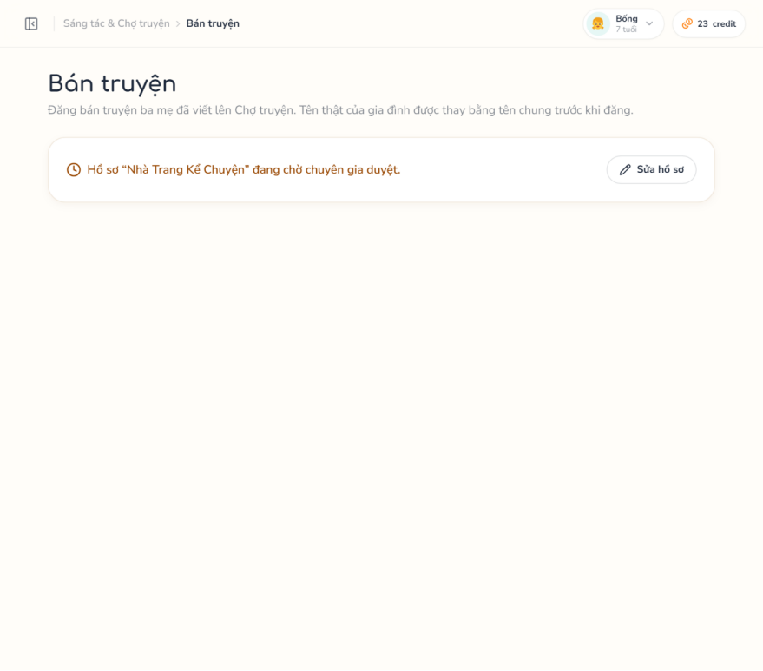
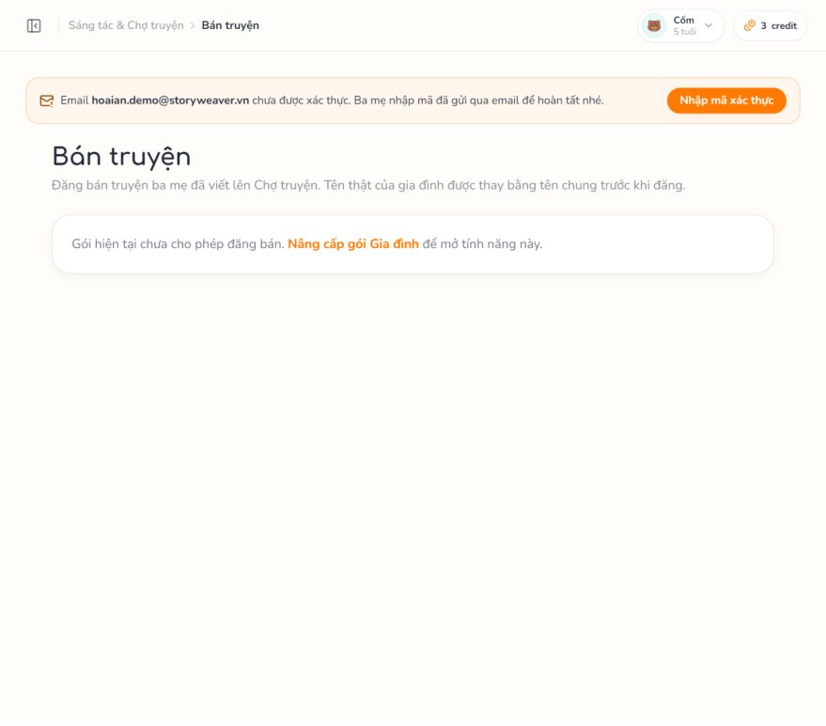
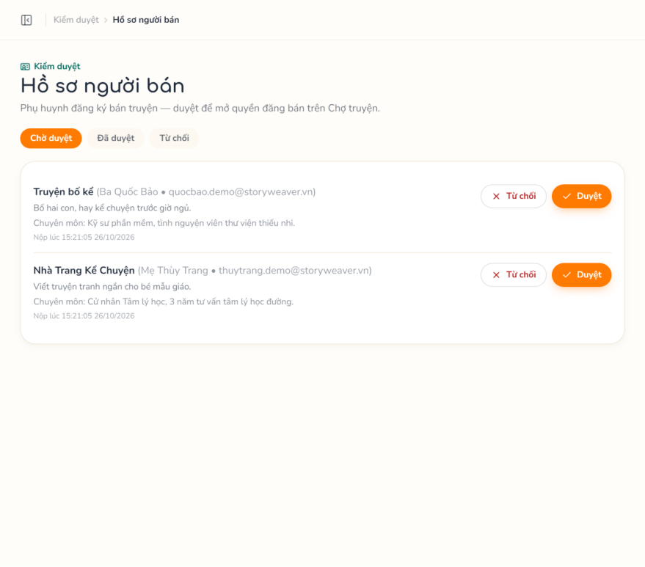

3.7.2 Submit Story for Sale & Moderate
Function trigger: Seller clicks “New listing”; Specialist claims a submission from the review queue.
Function description: Creates a de-personalised published copy of a reviewed private story and submits it; the Specialist claims it, reads every page, checks the 7-rule checklist on the web and approves, requests changes or rejects.
Actor/roles: Parent (Seller), Specialist
Purpose: Share stories with other families safely, with a human review of every published story.
Interface: New Listing; Moderation Overview; Review Workspace.
Data processing:
- Input data: storyId, title (3–200), description, priceVnd, aliases [{token, aliasName}]; reviewId, pageId + comment; decision, comment, issueStrike.
- Output data: Listing submitted → in_review → published / changes_requested / rejected.
Function details:
- Business rules:
  - BR-58: The seller sets the price: 0 (free) or 5,000–500,000 VND in steps of 1,000.
  - BR-59: The copy drops situation, moment summary and seed event, uses alias names, regenerates narration with generic names and copies ready scene images and the cover key; the template trace of checkpoints is kept.
  - BR-60: A claim lasts 30 minutes and is allowed only when the copy’s narration is ready.
  - BR-61: Approve only after 100% of pages are viewed; the pedagogical checklist stays on the web and is not sent; changes / rejects need a comment and reject can issue a strike.
- Normal case:
  - Seller chooses story, price and aliases.
  - System checks personal information and creates the copy, listing and submission review.
  - Specialist claims, views all pages and decides.
- Abnormal case:
  - AC-01: Not an approved seller → 403.
  - AC-02: Story not reviewed or incomplete → 422.
  - AC-03: Real names left → 422.
  - AC-04: Invalid price → 422.
  - AC-05: Claimed by another Specialist → 409.
  - AC-06: Pages not all viewed → 422.
  - AC-07: Missing comment → 422.
Screen layout:
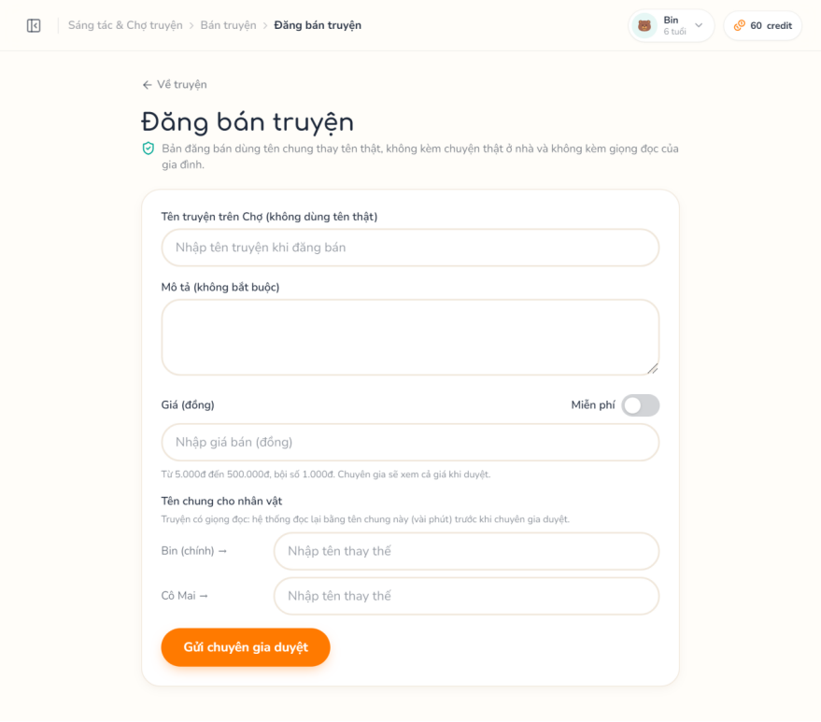
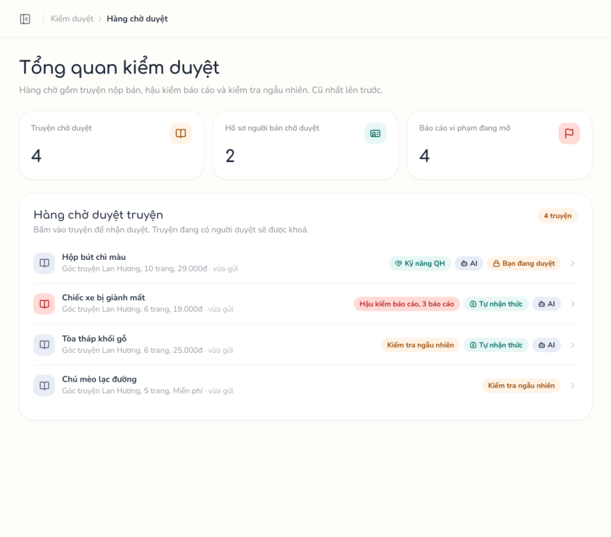
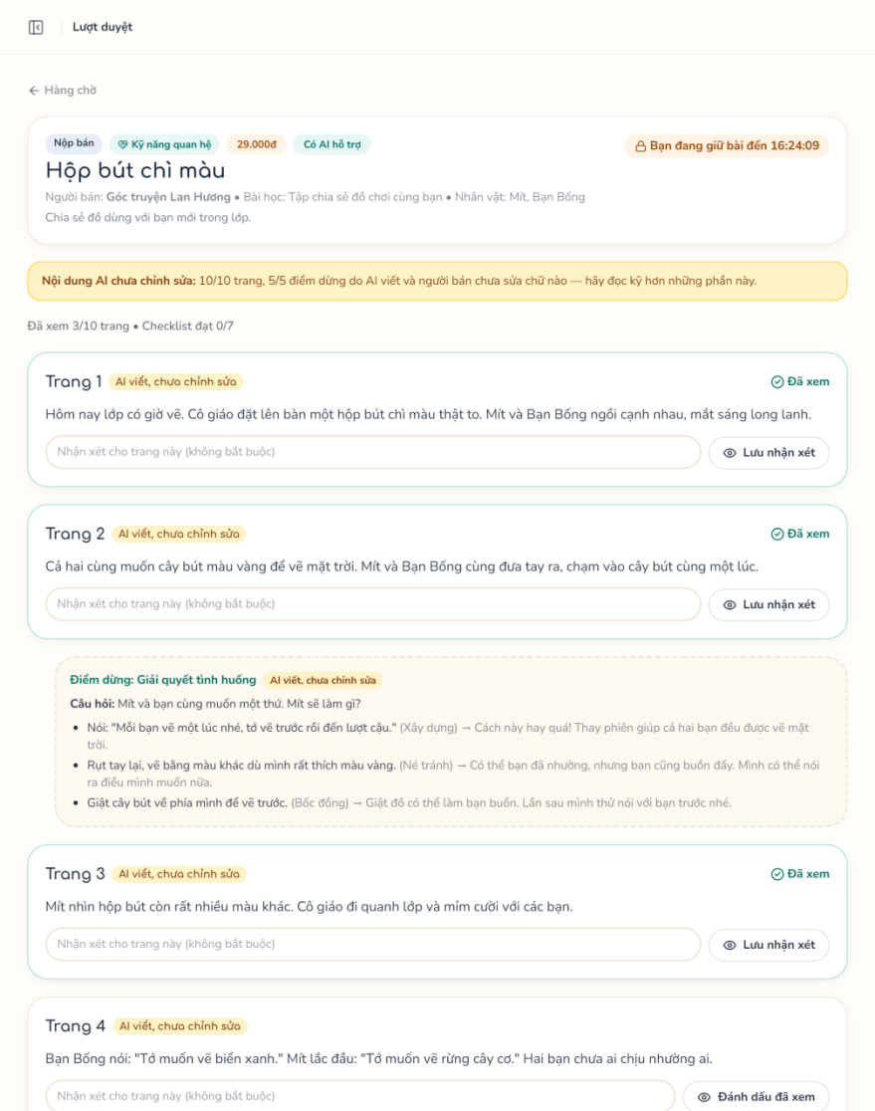

3.7.3 Earnings & Withdrawal
Function trigger: Seller opens Earnings on Selling; Admin opens Seller Withdrawals.
Function description: Shows held, available and withdrawing earnings; the seller sets the bank account and requests a withdrawal; the Admin transfers the money manually and marks the request paid, or rejects it (money returned). Held earnings are released by cron.
Actor/roles: Parent, Admin
Purpose: Pay sellers their revenue under control.
Interface: Selling (Bank Account + Withdrawal Form); Admin Seller Withdrawals.
Data processing:
- Input data: bankBin, bankAccountNumber, accountName; amountVnd; withdrawalId, reason.
- Output data: Earnings summary; withdrawal requested → paid / rejected / cancelled.
Function details:
- Business rules:
  - BR-62: Earnings never convert to credits.
  - BR-63: Minimum amount market.min_withdrawal_vnd (default 50,000 VND; Admin sets 10,000–10,000,000); a bank account changed less than 24 h ago blocks withdrawal; one open request per seller.
  - BR-64: Only requested items can be approved, rejected or cancelled; rejecting or cancelling returns the held money.
- Normal case:
  - Parent (Seller) sets the bank account and requests an amount.
  - Admin transfers the money from the bank app and marks the request paid (optional bank reference).
- Abnormal case:
  - AC-01: No bank account → 422.
  - AC-02: Below minimum or insufficient → 422.
  - AC-03: Open request exists → 409.
  - AC-04: Seller not approved → 403.
  - AC-05: Already handled → 409.
Screen layout:
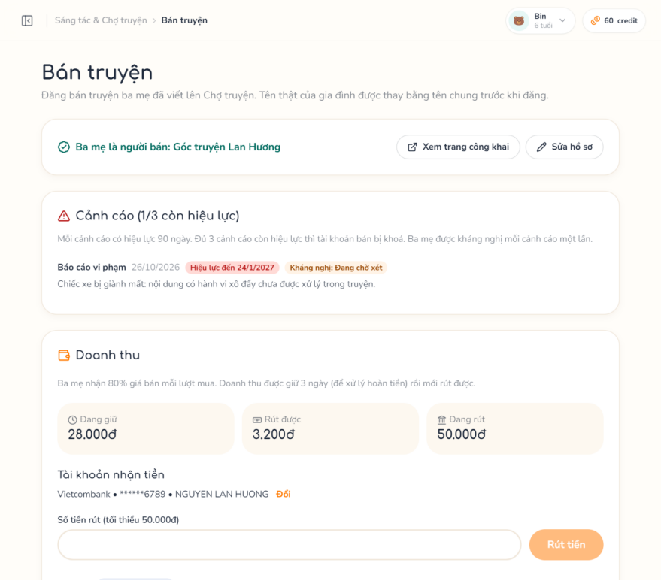
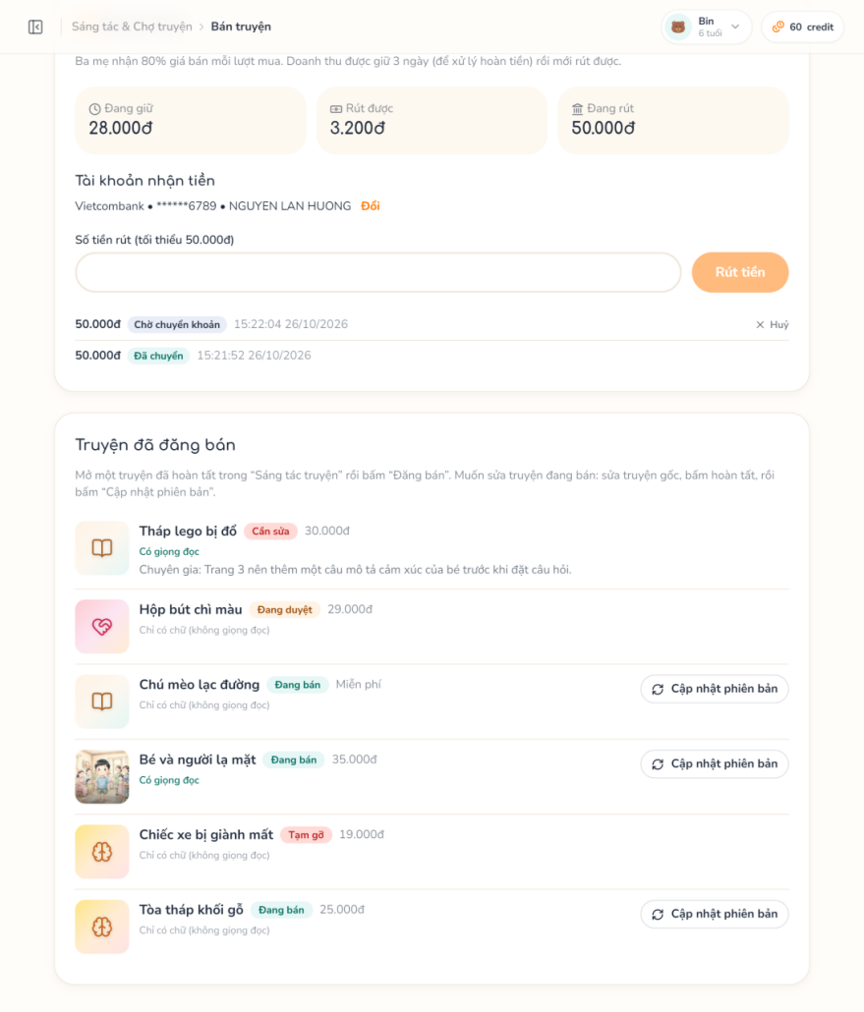
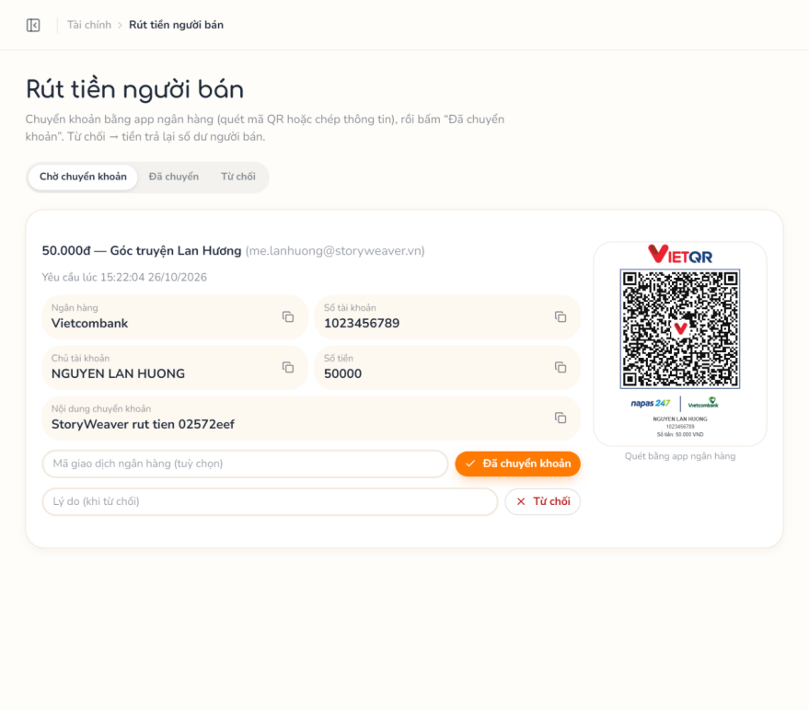

3.7.4 Reports, Strikes, Audits & Appeals
Function trigger: Parent reports a listing or review; Specialist opens the monitoring screens; Seller appeals a strike; Admin opens Strike Appeals.
Function description: Reports reaching the threshold auto-suspend a listing and open a follow-up review; Specialists dismiss reports, keep or take down listings, issue strikes, run random audits, hide reviews and block AI usage; sellers appeal strikes and the Admin decides.
Actor/roles: Parent (Seller), Specialist, Admin
Purpose: Community safety and fair enforcement after publication.
Interface: Report Story Dialog; Content Reports; Suspended Stories; Creator Strikes (Strike Modal); Random Audits; AI Usage Alerts; Strike Appeal Form; Admin Strike Appeals.
Data processing:
- Input data: listingId, category, pageId, description; reportId; strike data; userId + block until; strikeId, reason; appealId, approve, note.
- Output data: Report, review, strike and appeal statuses.
Function details:
- Business rules:
  - BR-65: Distinct reporters within 24 h ≥ moderation.report_threshold (default 3) → listing suspended + follow-up review.
  - BR-66: Take down archives the listing and issues a strike; active strikes ≥ 3 suspend the seller; strikes expire after 90 days.
  - BR-67: moderation.audit_per_week random audits per week.
  - BR-68: One appeal per active strike; the issuer of a strike cannot decide its appeal; an approved appeal revokes the strike and reinstates the seller when active strikes fall below the limit.
- Normal case:
  - Parent reports a listing or review with a category; at the threshold the listing is suspended and a follow-up review opens.
  - Specialist dismisses reports, keeps or takes down the listing (with a strike), runs random audits, hides reviews or blocks AI usage.
  - Seller appeals an active strike; an Admin who did not issue it approves or rejects the appeal.
- Abnormal case:
  - AC-01: Report own listing → 422.
  - AC-02: Same listing already reported by this parent → 409.
  - AC-03: Strike already appealed → 409; strike expired or revoked → 422.
  - AC-04: Issuer decides the appeal of their own strike → 403.
  - AC-05: Report or appeal already handled → 409.
Screen layout:

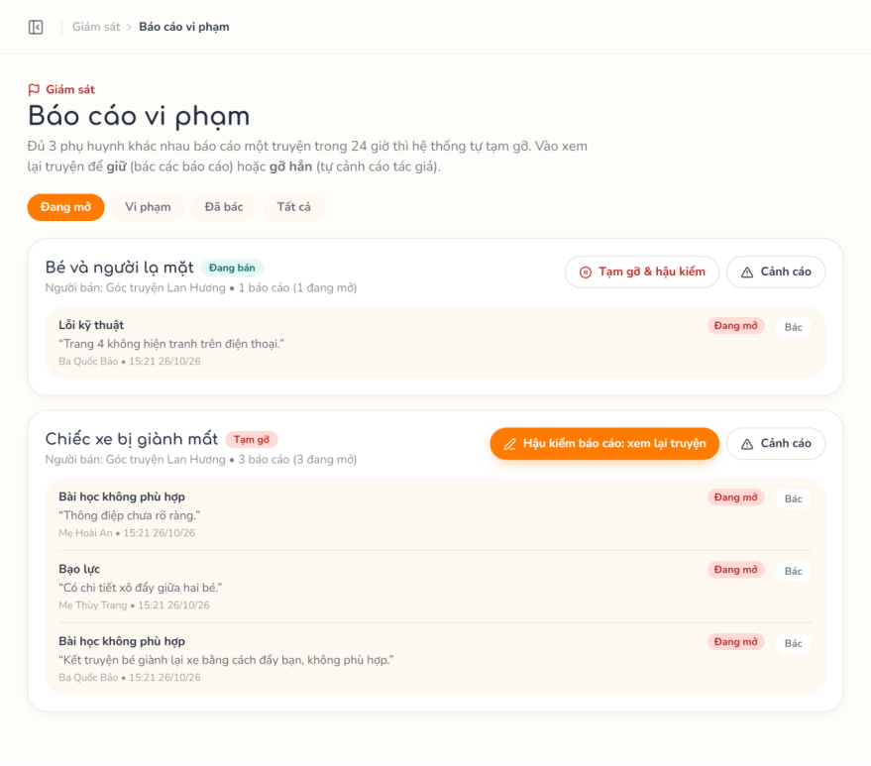
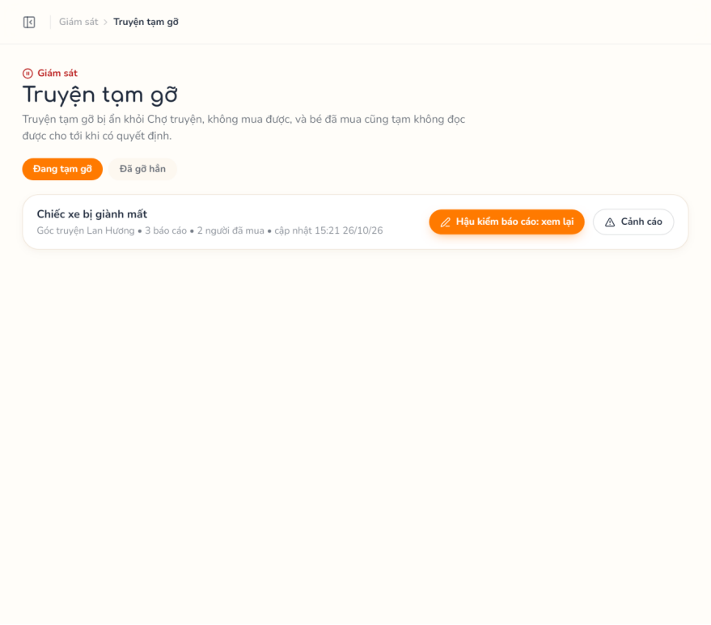
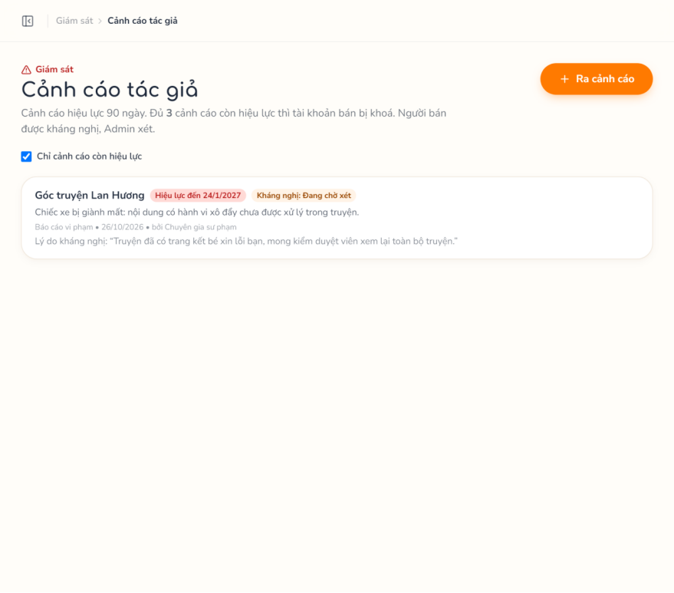
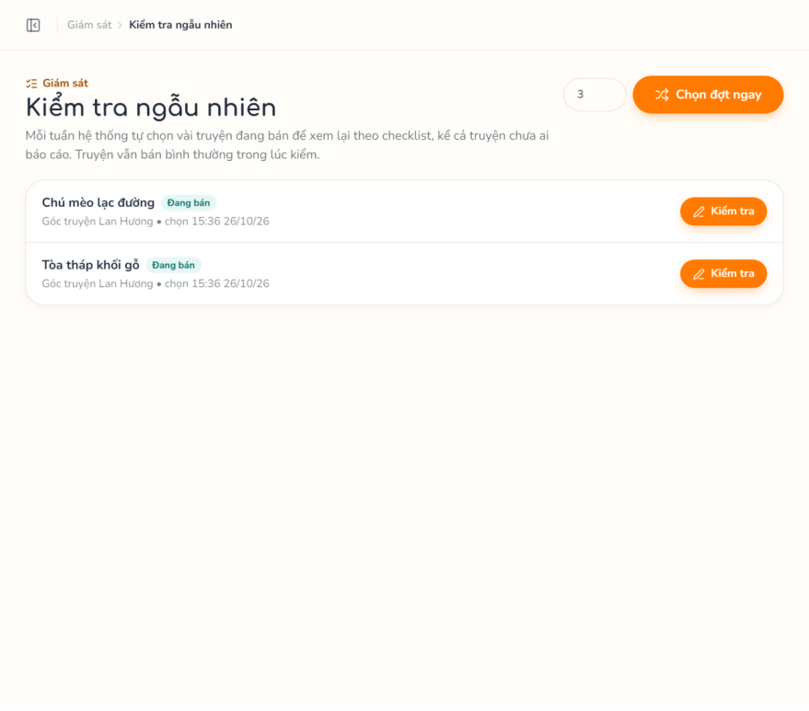
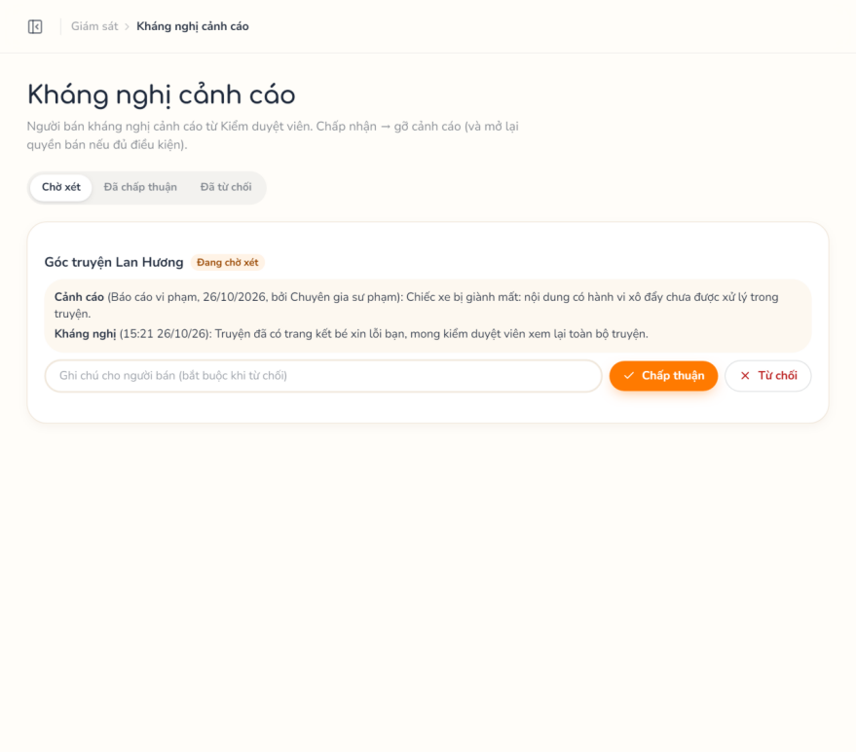

3.8 Administration

3.8.1 Manage Accounts & Audit Logs
Function trigger: Admin opens Accounts or Audit Logs.
Function description: Lists accounts by role, status and keyword, locks / unlocks them, creates Specialist accounts and views the log of Admin and Specialist actions.
Actor/roles: Admin
Purpose: User governance and accountability.
Interface: Accounts (Create Specialist Modal); Audit Logs.
Data processing:
- Input data: role, status, search, page; userId, isActive; specialist data; action prefix, actor, date range.
- Output data: Account list; log entries with before / after state.
Function details:
- Business rules:
  - BR-69: Every Admin and Specialist change is written to admin_audit_logs, which is append-only.
- Normal case:
  - Admin filters, locks or creates accounts.
  - Admin filters the audit log.
- Abnormal case:
  - AC-01: Account not found → 404.
  - AC-02: Email or username taken → 409.
Screen layout:
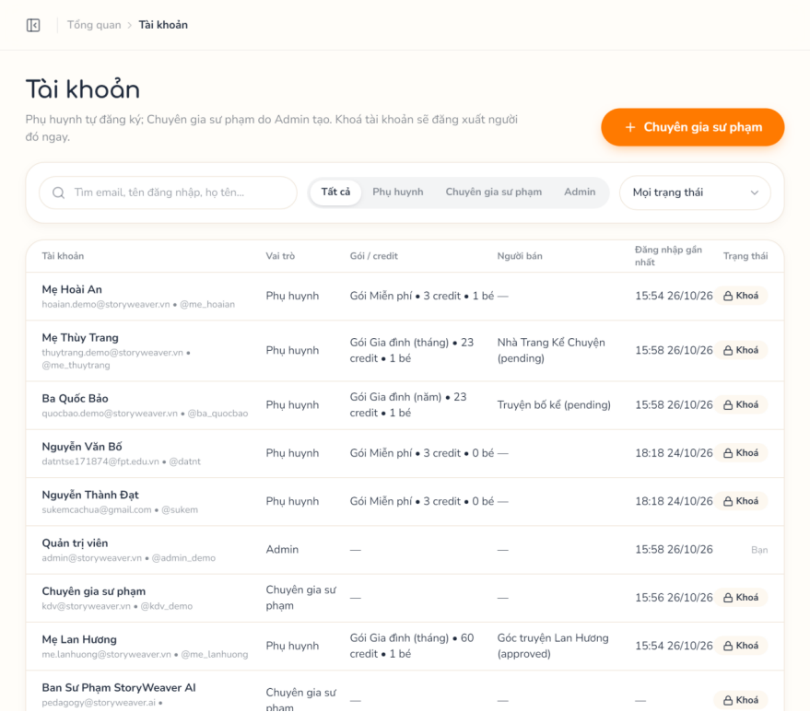
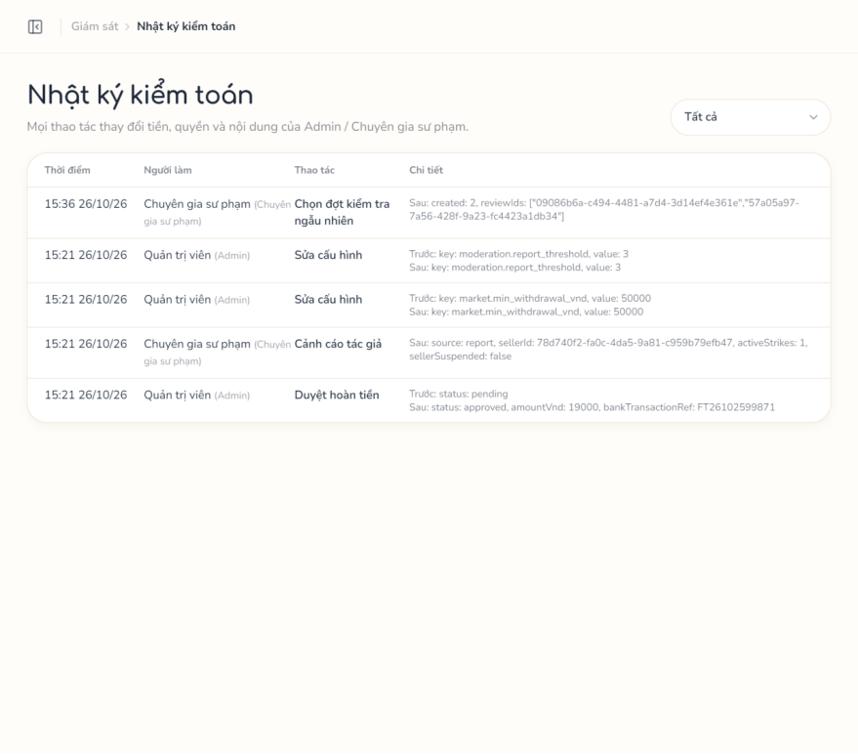

3.8.2 Configure Plans & Platform Settings
Function trigger: Admin opens Plans & Pricing or AI Configuration.
Function description: Creates and edits subscription plans and edits registered platform settings: AI credit costs, marketplace and refund, content monitoring.
Actor/roles: Admin
Purpose: Business configuration without code changes.
Interface: Plans & Pricing (Plan Form Modal); AI Configuration.
Data processing:
- Input data: plan fields (code, name, durationMonths, priceVnd, creditsPerMonth, maxChildren, maxCharacters, canSell, isActive); setting key + value.
- Output data: Updated configuration.
Function details:
- Business rules:
  - BR-70: Only keys declared in settingsRegistry can be edited and are validated by type and range.
  - BR-71: AI providers and keys are configured in the ai/ service environment, not on the web.
- Normal case:
  - Admin edits and saves.
- Abnormal case:
  - AC-01: Unknown key or invalid value → 422.
  - AC-02: Plan not found → 404.
Screen layout:
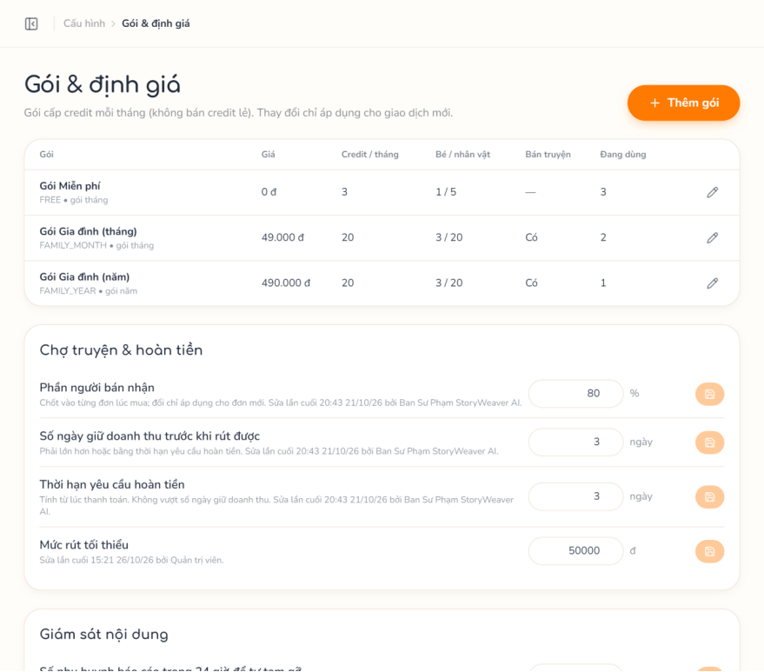
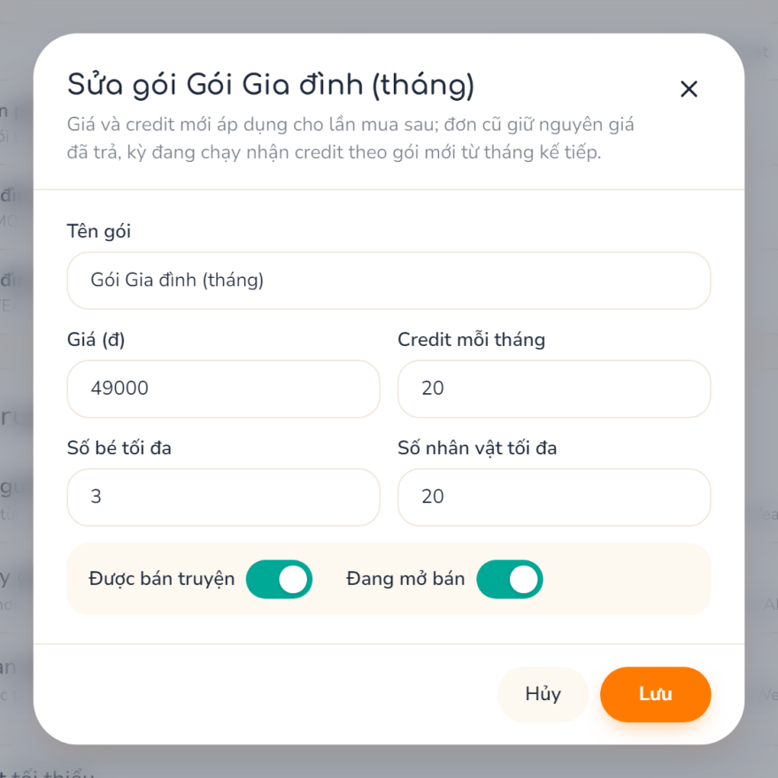
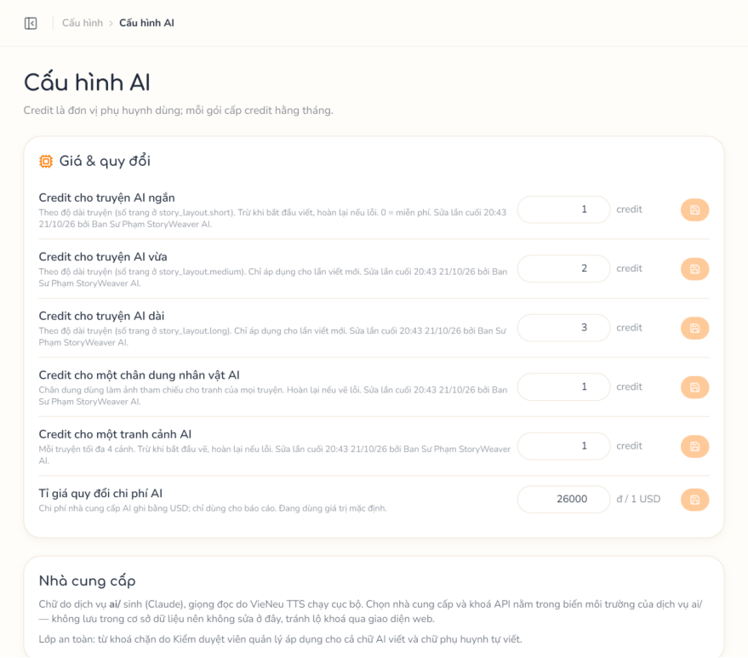

3.8.3 Finance Report
Function trigger: Admin opens Dashboard or Revenue Report.
Function description: Shows paid amount, platform share and seller payable by period with a daily chart; reconciles wallet balances with the ledger and paid orders without webhook and recomputes listing counters.
Actor/roles: Admin
Purpose: Financial oversight.
Interface: Dashboard; Revenue Report.
Data processing:
- Input data: period.
- Output data: Figures and chart; list of mismatches.
Function details:
- Business rules:
  - BR-72: Reconciliation reports mismatches and never changes money automatically; only listing counters can be fixed.
- Normal case:
  - Admin selects a period and views the report.
- Abnormal case:
  - AC-01: No data → empty report.
  - AC-02: Period other than today / 7d / 30d / 90d / year → 400; no period → 30d.
  - AC-03: Reconciliation finds mismatches → they are listed for the Admin; no money is changed (BR-72).
  - AC-04: User who is not an Admin → 403.
Screen layout:
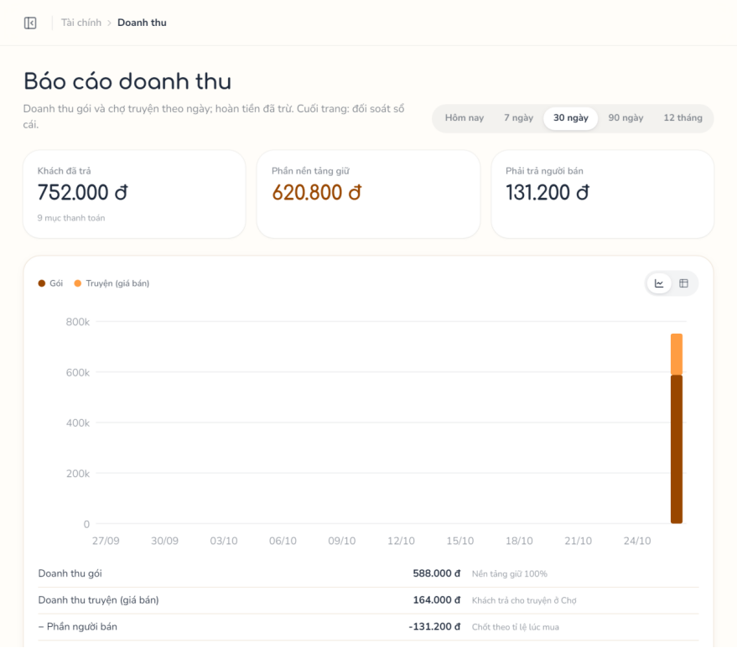

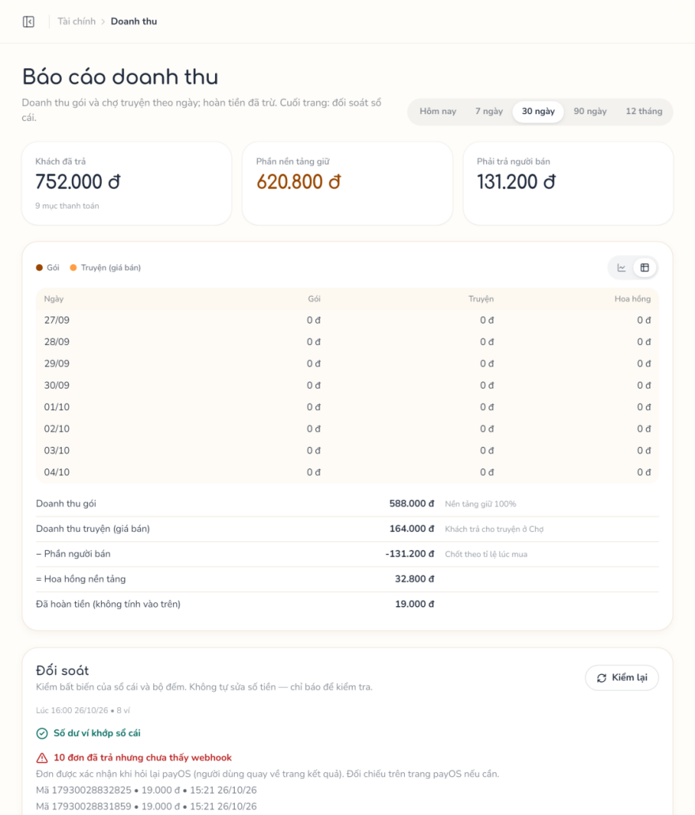

4. Non-Functional Requirements

4.1 External Interfaces
Interface | Description
User interface | Responsive web application (React 19 + Vite) in Vietnamese for desktop, tablet and phone; Kid Mode is zero-text with large touch targets for tablets.
Hardware interface | No special hardware. Kid Mode uses the device speaker / headphones for narration.
Software interface | REST API /api/v1 (JSON, JWT) documented with Swagger; PostgreSQL 16 (Docker, in development and on the production VM); Redis + BullMQ; internal HTTP to the Python AI service (internal token).
Third-party services | payOS (VietQR payment links, webhook); Cloudflare (Pages hosting, Tunnel ingress); Cloudinary (authenticated media, signed URLs); Anthropic Claude / Google Gemini (story text); VieNeu-TTS (self-hosted Vietnamese TTS); Cloudflare Workers AI – FLUX.2 klein (images); Brevo / SMTP (email).
Data sent to AI | Only tokenized story text ({NVx}), lesson template slots and appearance descriptions; real names of children and characters are never sent to the LLM or image model. Narration of private stories contains real names and is stored as private assets.

4.2 Quality Attributes

4.2.1 Usability
- The interface is in Vietnamese; error messages are Vietnamese and explain how to fix the problem.
- Kid Mode needs no reading: navigation by pictures and audio, large touch targets.
- Long AI tasks show progress (generation status, narration progress) with a retry action.

4.2.2 Security & Privacy
- JWT access tokens with rotating hashed refresh tokens; role-based access (parent, specialist, admin) and scoped kid session tokens.
- Another user’s story returns 404 so its existence is not revealed.
- No photo uploads; children’s real names are replaced by tokens before any AI request; published copies use alias names (0 real names in AI payloads and published copies).
- Media are Cloudinary authenticated assets served by expiring signed URLs; secrets stay in server environment variables.
- Correct checkpoint answers are never sent to the child’s device.

4.2.3 Performance
- AI text draft: target ≤ 30 s at p95 measured from ai_requests timestamps.
- Narration and images of an 8-page story complete as background jobs within 5 minutes.
- Kid Mode makes no AI call during playback; page transition ≤ 1 s.

4.2.4 Reliability & Financial integrity
- payOS webhooks are signature-validated, logged and processed idempotently; only fulfillOrder changes an order to paid.
- All balance changes are written to an append-only ledger with deterministic idempotency keys in the same transaction (wallet locked FOR UPDATE); 0 duplicate entries after webhook replay or double cron run.
- Cron jobs are idempotent; failed AI jobs release held credits; stale jobs are failed automatically.

4.2.5 Maintainability
- Node.js backend is decoupled from the stateless Python AI service by a documented contract; AI and storage providers are pluggable (mock / local / cloud) by configuration.
- Modular layered structure (routes → service / store → Prisma); pure business rules in modules/*/lib with unit tests; schema changes through Prisma migrations; API documented in Swagger.

5. Requirement Appendix

5.1 Business Rules
ID | Rule Definition
BR-01 | Email and username are unique.
BR-02 | Every new parent receives the Free plan through ensureFreeSubscription; credits come only from plans.
BR-03 | The verification code is one-time and valid for 24 hours; resending requires sign-in and is allowed once every 60 seconds.
BR-04 | Refresh tokens are stored hashed and rotated on every use; a used or expired token cannot be reused.
BR-05 | Locked accounts cannot sign in.
BR-06 | Recovery codes are one-time and expire 1 hour after they are issued; requesting a new code voids any unused one; the new password must differ from the current one.
BR-07 | The number of children is limited by the current plan.
BR-08 | Deleting a child is a soft delete.
BR-09 | The Kid PIN has 4–6 digits and is stored hashed; it is set once and then changed with the current PIN.
BR-10 | Each child has at most one representative character (characters.child_id unique).
BR-11 | The portrait prompt uses the appearance only, never the real name, and costs ai_cost.character_portrait credits (hold → consume / release).
BR-12 | The number of characters is limited by the plan.
BR-13 | Model story requires an active topic and does not accept a situation; Handwritten (custom length) may have no topic.
BR-14 | Family story requires an analysis made within 2 hours for the same owner, the same tokenised story and the same characters (analysisToken).
BR-15 | The analysis is synchronous, costs no credit, is limited by limits.story_analysis_per_day (default 30) and only chooses sub-skills that have a published template version; the AI never sets scores or answers.
BR-16 | A family story keeps 1–2 sub-skills (position 1 = main) in story_sub_skills; scored = false means “just tell the story” with reflection questions only.
BR-17 | Real names in the situation are replaced by tokens before storage or any AI call.
BR-18 | Cost = ai_cost.story_text.<length> credits: hold on request, consume on success, release on failure.
BR-19 | Handwritten stories cannot use AI writing; a story already played by a child cannot be regenerated; one generation at a time per story.
BR-20 | A Specialist can temporarily block AI usage of a parent.
BR-21 | Checkpoints of AI stories follow the Specialist templates and cannot be edited (422); handwritten stories have 4–20 pages and 0–6 checkpoints, which are never scored (a reflection may only be placed after the last page).
BR-22 | The told story (situation) and the characters of a family story cannot be changed after creation (409).
BR-23 | ai_cost.character_portrait and ai_cost.scene_image credits, hold → consume / release.
BR-24 | Image prompts use appearance descriptions only; there is no automatic image safety classifier, the reviewer decides.
BR-25 | The cover is one scene with a ready image (default scene 1); without an image the web draws a cover in the competency colour.
BR-26 | All pages and checkpoints must be complete and free of blocked keywords before review.
BR-27 | Narration costs no credit.
BR-28 | A story is ready for a child only when it is reviewed, all narration clips are ready if narration is on, and (for a purchased story) its listing is not suspended or archived (loadReadiness); this gate applies to the bookshelf and to starting a play.
BR-29 | Only stories the parent owns or holds an active entitlement for can be added.
BR-30 | Sub-skills are the standard CASEL items (casel_text_en kept for traceability); Specialists cannot add or delete them.
BR-31 | ageMin ≤ ageMax, within 1–18.
BR-32 | A topic has 1–3 sub-skills of its competency; a topic with stories keeps its competency and is retired instead of deleted.
BR-33 | At most one draft per template; a version can be published only when complete (assertVersionComplete).
BR-34 | A template used by checkpoints can only be disabled, not deleted.
BR-35 | Flagged checkpoints are not scored and are excluded from reports; marking OK restores them.
BR-36 | Report defaults: last 5 answers, minimum 3, thresholds 0.5 and 0.8.
BR-37 | block stops both AI and parent-written text; warn only warns.
BR-38 | A PIN must be set before entering Kid Mode.
BR-39 | The kid token is accepted only by /kid/* endpoints and carries only the child.
BR-40 | Correct answers are never sent to the device.
BR-41 | Only the first choice of the first play is scored; score, skill, sub-skill and template version are snapshotted into checkpoint_answers.
BR-42 | Reflection, unscored, flagged, handwritten or template-less checkpoints have score null; a wrong template binding is not scored and is logged, never a 500 to the child.
BR-43 | At emotion and perspective checkpoints a wrong first choice gives a hint and a second try, and a second wrong choice reveals the correct answer; problem-solving checkpoints give the feedback of the chosen option; reflection has no right or wrong answer and cannot be skipped.
BR-44 | Level from the last N answers (minimum M) with the Specialist thresholds; competency level = lowest sub-skill level.
BR-45 | Flagged checkpoints are ignored.
BR-46 | Buying a different plan starts a new period at once: it closes the active one, keeps the remaining credits once and grants credits_per_month; buying the same plan again extends the current period; unused credits expire at the next monthly grant.
BR-47 | Only fulfillOrder moves an order from pending | expired to paid, with a conditional update.
BR-48 | The webhook is logged and fulfils only when the signature is valid, the code is 00 and the amount matches.
BR-49 | Only published listings of approved sellers are shown.
BR-50 | Price and seller share are snapshotted in order_items; a paid sale records the seller earning (market.seller_share_rate, default 80%) held for market.earning_hold_days.
BR-51 | A duplicate purchase of an owned story opens a refund request automatically.
BR-52 | Only buyers whose child completed the story may review.
BR-53 | One seller reply per review; a hidden review cannot be edited.
BR-54 | Only a paid item with price > 0, requested within market.refund_window_days of payment (default 3 days; Admin sets 1–30, never more than market.earning_hold_days), with one request per item.
BR-55 | Refunds are transferred manually by the Admin; if the seller has already withdrawn that earning, approval is refused (422) and the request stays pending to be settled with the seller.
BR-56 | The plan must allow selling (can_sell).
BR-57 | A rejected applicant may re-apply; a suspended seller cannot; only pending applications can be decided.
BR-58 | The seller sets the price: 0 (free) or 5,000–500,000 VND in steps of 1,000.
BR-59 | The copy drops situation, moment summary and seed event, uses alias names, regenerates narration with generic names and copies ready scene images and the cover key; the template trace of checkpoints is kept.
BR-60 | A claim lasts 30 minutes and is allowed only when the copy’s narration is ready.
BR-61 | Approve only after 100% of pages are viewed; the pedagogical checklist stays on the web and is not sent; changes / reject need a comment and reject can issue a strike.
BR-62 | Earnings never convert to credits.
BR-63 | Minimum amount market.min_withdrawal_vnd (default 50,000 VND; Admin sets 10,000–10,000,000); a bank account changed less than 24 h ago blocks withdrawal; one open request per seller.
BR-64 | Only requested items can be approved, rejected or cancelled; rejecting or cancelling returns the held money.
BR-65 | Distinct reporters within 24 h ≥ moderation.report_threshold (default 3) → listing suspended + follow-up review.
BR-66 | Take down archives the listing and issues a strike; active strikes ≥ 3 suspend the seller; strikes expire after 90 days.
BR-67 | moderation.audit_per_week random audits per week.
BR-68 | One appeal per active strike; the issuer of a strike cannot decide its appeal; an approved appeal revokes the strike and reinstates the seller when active strikes fall below the limit.
BR-69 | Every Admin and Specialist change is written to admin_audit_logs, which is append-only.
BR-70 | Only keys declared in settingsRegistry can be edited and are validated by type and range.
BR-71 | AI providers and keys are configured in the ai/ service environment, not on the web.
BR-72 | Reconciliation reports mismatches and never changes money automatically; only listing counters can be fixed.

5.2 Common Requirements

ID | Requirement Name | Description
CR-01 | Pagination | List endpoints support page / limit (default 10, marketplace 8, maximum 50–100).
CR-02 | Standard response | Every API returns the ApiResponse format (success, message, data); errors return HTTP status with a Vietnamese message and field errors.
CR-03 | Validation | Every request body / query / params is validated by Zod before reaching the service.
CR-04 | Vietnam time | Dates such as “today”, week start and report periods use Vietnam time (UTC+7).
CR-05 | Soft delete | Children, characters and stories are soft-deleted (deleted_at); revoked / hidden records keep their history.
CR-06 | Ownership | Parents can only access their own children, characters and stories; others return 404.
CR-07 | Audit | Admin and Specialist decisions are written to admin_audit_logs.
CR-08 | Configuration | Business parameters are read from platform_settings, not hard-coded.
CR-09 | Money | Amounts are integer VND (BigInt, serialized as string); credits are integers.

5.3 Application Messages List

# | Message code | Message Type | Context | Content
Authentication & Account
1 | MSG-01 | ERROR | Register with an existing email | Email is already registered
2 | MSG-02 | ERROR | Register with an existing username | Username is already taken
3 | MSG-03 | ERROR | Wrong login credentials | Invalid email/username or password
4 | MSG-04 | ERROR | Deactivated account signs in | Your account has been deactivated. Please contact support.
5 | MSG-05 | ERROR | Refresh token reused / expired | Invalid or already used refresh token / Refresh token has expired
6 | MSG-06 | ERROR | Recovery code invalid | Mã khôi phục không đúng, đã dùng hoặc đã hết hạn. Ba mẹ gửi lại mã mới nhé.
7 | MSG-07 | ERROR | New password equals current | Mật khẩu mới phải khác mật khẩu hiện tại.
8 | MSG-08 | ERROR | Verification code invalid | Mã xác thực không hợp lệ hoặc đã được sử dụng
9 | MSG-09 | ERROR | Verification code expired | Mã xác thực đã hết hạn. Vui lòng yêu cầu gửi lại mã.
10 | MSG-10 | ERROR | Resend code too soon | Vui lòng đợi {n} giây trước khi gửi lại mã
11 | MSG-11 | ERROR | Email already verified | Email đã được xác thực
12 | MSG-12 | ERROR | Enter Kid Mode without PIN | You must set a Kid Exit PIN before entering Kid Mode
13 | MSG-13 | ERROR | Wrong exit PIN | Incorrect Kid Exit PIN
14 | MSG-14 | ERROR | Kid session expired | Kid session has expired
Family Profile
15 | MSG-15 | ERROR | Child already has a character | Bé đã có nhân vật “{name}” — ba mẹ sửa nhân vật đó thay vì tạo thêm.
16 | MSG-16 | ERROR | Character limit of plan | Gói hiện tại cho tối đa {max} nhân vật. Ba mẹ xoá bớt nhân vật không dùng hoặc nâng cấp gói nhé.
17 | MSG-17 | ERROR | Portrait without appearance | Hãy mô tả ngoại hình nhân vật trước khi tạo chân dung.
18 | MSG-18 | ERROR | Portrait already running | Chân dung nhân vật này đang được vẽ.
Story Creation & AI
19 | MSG-19 | ERROR | AI story without topic | Truyện AI cần chọn chủ đề.
20 | MSG-20 | ERROR | Model story with a situation | Chuyện mẫu không nhận lời kể; hãy chọn "Kể chuyện nhà mình"
21 | MSG-21 | ERROR | Analysis expired or changed | Kết quả phân tích đã hết hạn hoặc không khớp với lời kể / nhân vật. Hãy bấm "Xem bé sẽ tập gì" để phân tích lại.
22 | MSG-22 | ERROR | Daily analysis limit | Hôm nay ba mẹ đã dùng hết {limit} lượt phân tích lời kể. Hãy thử lại vào ngày mai nhé.
23 | MSG-23 | ERROR | Analysis failed | Chưa phân tích được, thử lại
24 | MSG-24 | ERROR | Cover scene without image | Cảnh này chưa có ảnh
25 | MSG-25 | ERROR | Topic retired | Chủ đề này đã ngừng sử dụng, vui lòng chọn chủ đề khác.
26 | MSG-26 | ERROR | Blocked keyword in text | Truyện có từ không phù hợp cho bé. Hãy sửa lại chỗ được đánh dấu.
27 | MSG-27 | ERROR | AI writing on custom story | Truyện tự viết không dùng được AI viết chữ. Hãy chỉnh sửa trực tiếp các trang.
28 | MSG-28 | ERROR | Generation already running | Truyện đang được AI viết, vui lòng đợi xong.
29 | MSG-29 | ERROR | Regenerate a played story | Truyện đã được bé đọc nên không thể viết lại; hãy tạo truyện mới.
30 | MSG-30 | ERROR | Queue unavailable | Hệ thống AI đang tạm gián đoạn, credit đã được hoàn lại. Vui lòng thử lại sau ít phút.
31 | MSG-31 | ERROR | AI blocked by specialist | Quyền dùng AI viết truyện đang tạm khoá đến {time} do nhiều lần nội dung bị chặn. Ba mẹ vẫn tự viết truyện được.
32 | MSG-32 | ERROR | Edit AI checkpoint | Câu hỏi của truyện AI theo khung của chuyên gia, không sửa được.
33 | MSG-33 | ERROR | Not enough credit for images | Ba mẹ không đủ credit để vẽ tranh.
34 | MSG-34 | ERROR | Narration before review | Hãy bấm hoàn tất truyện trước khi tạo giọng đọc.
35 | MSG-35 | ERROR | TTS unavailable | Hệ thống giọng đọc đang tạm gián đoạn. Vui lòng thử lại sau ít phút.
36 | MSG-36 | ERROR | Change characters after content | Truyện đã có nội dung nên không thể đổi nhân vật. Hãy tạo truyện mới để dùng nhân vật khác.
37 | MSG-37 | INFO | Narration retry accepted | Đang tạo lại giọng đọc
Pedagogical Library
38 | MSG-38 | ERROR | Age range invalid | Tuổi tối thiểu phải nhỏ hơn hoặc bằng tuổi tối đa.
39 | MSG-39 | ERROR | Template in use deleted | Mẫu đã có {n} điểm dừng dùng, chỉ tắt được.
40 | MSG-40 | ERROR | Publish without draft | Mẫu không có bản nháp để ban hành.
Publishing & Moderation
41 | MSG-41 | ERROR | Plan cannot sell | Gói hiện tại chưa cho phép đăng bán. Ba mẹ nâng cấp gói Gia đình để đăng bán truyện.
42 | MSG-42 | ERROR | Seller not approved | Ba mẹ cần được duyệt hồ sơ người bán trước khi đăng bán.
43 | MSG-43 | ERROR | Story not reviewed | Hãy bấm hoàn tất truyện trước khi đăng bán.
44 | MSG-44 | ERROR | Invalid listing price | Giá bán là 0đ (miễn phí) hoặc từ 5.000đ đến 500.000đ, làm tròn đến 1.000đ.
45 | MSG-45 | ERROR | Personal info left in copy | Chưa gỡ hết thông tin cá nhân của gia đình.
46 | MSG-46 | ERROR | Review claimed by another | Specialist khác đang duyệt bài này.
47 | MSG-47 | ERROR | Approve with incomplete coverage | Cần xem hết {total} trang (đã xem {viewed}) trước khi duyệt.
48 | MSG-48 | ERROR | Decision without comment | Hãy ghi nhận xét để người bán biết cần sửa gì.
Marketplace & Payment
49 | MSG-49 | ERROR | Buy own story | Đây là truyện của ba mẹ, không cần mua.
50 | MSG-50 | ERROR | Buy owned story | Ba mẹ đã có truyện này.
51 | MSG-51 | INFO | Duplicate purchase refund | Tự động: mua trùng — phụ huynh đã sở hữu truyện này từ đơn trước, cần hoàn tiền.
52 | MSG-52 | ERROR | Review before child finished | Bé đọc hết truyện này rồi ba mẹ đánh giá nhé.
53 | MSG-53 | ERROR | Duplicate review reply | Ba mẹ đã trả lời đánh giá này rồi.
54 | MSG-54 | ERROR | Duplicate refund request | Ba mẹ đã gửi yêu cầu hoàn tiền cho giao dịch này.
55 | MSG-55 | ERROR | Approve refund without reference | Nhập mã giao dịch chuyển trả cho phụ huynh.
Kid Mode
56 | MSG-56 | ERROR | Answer in finished session | Lượt đọc này đã kết thúc.
57 | MSG-57 | ERROR | Choice does not match type | Lựa chọn không đúng với kiểu điểm dừng.
Earnings & Withdrawal
58 | MSG-58 | ERROR | Withdraw without bank account | Hãy nhập tài khoản ngân hàng nhận tiền trước.
59 | MSG-59 | ERROR | Bank changed < 24 h | Vừa đổi tài khoản ngân hàng: rút được sau 24 giờ kể từ lúc đổi.
60 | MSG-60 | ERROR | Below minimum | Số tiền rút tối thiểu là {min}đ.
61 | MSG-61 | ERROR | Open request exists | Đang có một yêu cầu rút tiền chưa xử lý xong.
62 | MSG-62 | ERROR | Insufficient balance | Số dư có thể rút không đủ.
63 | MSG-63 | ERROR | Mark paid twice | Yêu cầu không còn ở trạng thái chờ chuyển khoản.
Monitoring
64 | MSG-64 | ERROR | Report own listing | Không báo cáo truyện của chính ba mẹ.
65 | MSG-65 | ERROR | Duplicate report | Ba mẹ đã báo cáo truyện này rồi. Cảm ơn ba mẹ, kiểm duyệt viên đang xem xét.
66 | MSG-66 | ERROR | Duplicate appeal | Ba mẹ đã kháng nghị cảnh cáo này rồi.
67 | MSG-67 | ERROR | Issuer decides own appeal | Người ra cảnh cáo không tự xét kháng nghị của cảnh cáo đó.

